EXHIBITION REVIEW
“Vancouver: Cai Guo Qiang”
©Susan Platt first published in Art Papers January February 2002
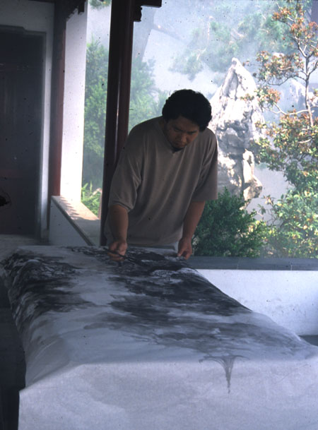
Cai Guo Qiang
Performing Chinese Ink Painting, 2001
Smoke machine, Chinese rice paper, ink, brushes, painting tables
and other painting paraphernalia
Sun Yat Sen Garden, Vancouver BC
Inside the walled and peaceful sanctuary of the Sun Yat Sen Garden in gritty, downtown Vancouver, BC, Cai Guo-Qiang asked three traditional Chinese ink painters, Cynthia Wu and Yu Long of Vancouver, and Charles Liu from Chicago to execute the works that form the basis for his new interrogation of art history, “Performing Chinese Ink Painting” (Dr. Sun Yat-Sen Classical Chinese Garden, Vancouver, B.C. July 24, 25, 26, 2001). Ink painting is a venerable Chinese artistic tradition historically practiced by a privileged intelligentsia. During many decades of Communist rule in China, it was sometimes vilified and suppressed as bourgeois and decadent, sometimes honored as great Chinese art. Cai Guo-Qiang is adding another layer to that history. “Performing” refers to the historical tradition of making ink painting for a private audience of friends as well as to the familiar Western idea of performance art.
The Sun Yat Sen Garden is an “authentic” Chinese classical garden based on the principles of yin and yang, created by 52 artisans over a period of 14 months in honor of the “father” of New China, Dr. Sun Yat Sen. At the same time, and the irony was one of the inspirations for this piece, the Garden is a constructed artifice in a modern city.
Cai Guo Qiang intervened in the garden by adding fog machines, which created a misty effect (and a rather loud noise when they expelled fog) the only element in the garden that was not part of the perfectly balanced yin and yang of the stones, trees and architecture. They both underscored the artificiality of the garden and brought it closer to a traditional landscape aesthetic.
The artists painted quickly, much more quickly than they were accustomed to according to Cynthia Wu, who said that normally an ink painting took her one week. The three artists were asked to complete one painting each day of the performance. Ink painting is also a literary art that incorporates poetry, so Wu, for example, included a poem of her father’s that invoked the wind. These three artists were all using the “wet” ink technique, which is more abstract, as opposed to the dry ink technique which traditionally is more figurative.
Part II of the performance was the exhibition of the completed paintings in the Contemporary Art Gallery, Vancouver (July 28 -September 23, 2001) along with a video of the three artists as they painted in the garden. The performance continued during the opening as the artists collaborated on a mural- scaled landscape painting.
In another venue in Vancouver, Cai Guo Qiang showed a video of his gunpowder explosions Projects for Extra Terrestrials and a gunpowder drawing Fountain created on August 2, 2001, at the Charles H. Scott Gallery ( August 3 -September 23, 2001). In the Scott Gallery he also presented a series of paintings each created in one day during the artist’s stay in Vancouver. They were seemingly in the tradition of Western abstraction (except that they were actually a representation of the video image of a specific event). But they were visually and aesthetically feeble. They seemed to declare the weakness of oil painting in comparison to the subtlety and complexity of ink painting.
The paintings also underscore the fact that Cai Guo-Qiang was not trained in painting, but in stage design. That is an important distinction from other Chinese ex patriot artists like Xu Bing and Wenda Gu both of whom trained as academic realists in oil painting, as well as in classical calligraphy and other historical techniques. Cai Guo-Qiang’s mega sized gunpowder performances (like adding ten thousand meters to the Great Wall of China) are one obvious result of his theatrical background. Another is the staged endeavor of Cultural Melting Bath (1997)which used 30 tons of Taihusu ( Tai Lake stones) flown in from China to the Queens Museum of Art as a setting for an herbal hot tub.
Taihusu stones also define “Performing Chinese Ink Painting” but in a much more humble way. Traditionally a scholar artist meditated on a small piece of these unusual perforated rocks in the privacy of his home as the basis for an entire landscape painting and a path to enlightenment. “Performing Chinese Ink Painting ”actually affirms the aesthetics and technical virtuosity of this tradition even as it underscores its artificiality and changes its creative tempo. Engaged as he is in an international avant-garde stance of ironic detachment and recontextualizing, Cai Guo-Qiang did not expect that “Performing Chinese Ink Painting” would work as an exhibition simply because these artists are incredibly good at what they do. That failure of irony can perhaps be explained by the fact that Cai Guo-Qiang’s father practiced traditional ink painting up until the Cultural Revolution, when Cai himself burned books from his father’s library.
But there is an irony here. These artists would not normally be visible in a Contemporary Art Gallery outside of China. They are traditional artists with no avant-garde pretensions or aspirations. In comparison, Ji Ruoxiao, another Chinese ink painter who creates intricate landscapes in the dry ink tradition, but expands the classical tradition with a personal expressionism, does show in contemporary art galleries. Her art would not fit in Cai Guo-Qiang’s project, because he required the clear dialectic of his own stance and the traditional approach. But that clever dialectic fell prey to his own emotional connection to ink painting. So far from being a colonizer of the landscape painters as he set the parameters and employed the artists to create works that would be subsumed under his name, he actually, against his own intent, kindled an appreciation of Chinese traditions.
Conceptually Cai Guo-Qiang’s work is an on-going negotiation between Chinese and Western ideas, but this negotiation is frequently drowned out by the artist’s love of spectacle. Fortunately that did not happen in “Performing Chinese Ink Painting.” The production of the traditional artists and Cai Guo-Qiang’s concepts interconnect in a provocative way that challenges and expands the Western viewer rather than just seducing us with gigantic scale and explosions. Luckily he shifted to a more nuanced idea just in time, before the explosions in New York took over our lives and dwarfed any pyrotechnics he could have possibly imagined.
©Susan Platt

