EXHIBITION REVIEW
“Rabbits, Cats, Horses and Hello Kitty?”
©Susan Platt first published in Art Papers July August 2003
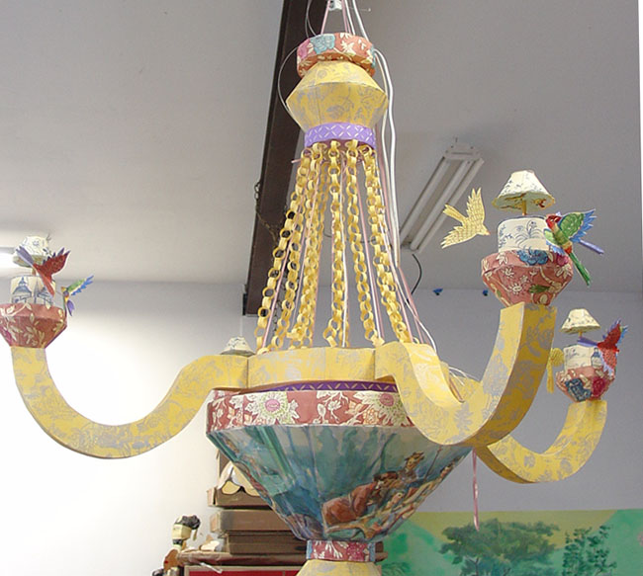

Maki Tamura’s installation “Vignette” appeared right in the middle of an exhibition of historical Japanese imagery of animals at the Seattle Asian Art Museum (December 21 – March 16, 2003). Seattle Art Museum deputy director Lisa Corrin initially asked Tamura to create an installation on the theme of “Hello Kitty.” Tamura, born in Japan and raised in Indonesia, expanded the topic to include a whole range of layered references to animals, colonialism, racism and eroticism.

Two pairs of hanging scrolls face each other at the entrance to create a type of ante-room such as you might find in an eighteenth century palace, handmade paper chandeliers in intricate shapes based on pagodas and ornamented with erotic watercolor paintings provide soft lighting, and finally the Victorian bed, with gauze curtains descending from above, jumps out of the gloom.

Tamura creates a subtle buildup to the bedroom, with its Hello Kitty spread, carpet and pillow. The hanging scrolls fall down the wall and out onto the floor. On mulberry paper (it is thin, strong and resistant to moisture) mounted on linen, Tamura paints with pastel colors in watercolor and uses linoleum blocks to transfer images from old books. The sweet colors are intentional, they underscore the colonial enterprise of reducing animals, people from Asian countries, and plants, all to decoration (sometimes known as Chinoiserie). As you look closer you see that some of the animals are based on Victorian natural history illustrations from encyclopedias, some are imaginary part/human part/ animal imaginary cartoon characters. Likewise the plants are exotica like palms that were transplanted by the South Pacific to botanical gardens in London. Floral patterns are based on Indonesian batiks, another highly mediated natural reference. On the facing wall, the two scrolls are full of eroticism, particularly Ukiyo-e (Floating world) couples engaged in sex. These explicit sexual scenes make obvious that this installation is not a shrine to a child-like cliché ( Hello Kitty is equally popular among adults in Japan), but rather, a layered feminist, post-colonial commentary.

The artist surrounded the bed itself with horizontal watercolors that mimic an actual wallpaper popular in the early 19th century based on Captain Cook’s voyages called “Savages of the South Pacific.” Tamura has recreated the lush tropical scenes that originally served as backdrops for dancing girls and village scenes. The bed itself has a surprising group of pillows: in addition to Hello Kitty, there are the Jackson 5, Mona Lisa and George Washington. The magnetic pull of the kitsch Kitty icon is mediated by its proximity to other icons.

The Jackson 5 was hugely popular in Japan in the sixties. But Tamura has another point to make here: the presence of African Americans on pillows in this sweet little Victorian “white girl’s” bedroom refers to the racist fear of miscegenation.

The cultural clichés that Tamura plays with in the bedroom, juxtaposed to the hanging scrolls, come together as a commentary on our preconceived expectations about the East as exotic, erotic, dangerous, decorative, and child-like. It is actually a brilliant subversion of the original request to do a “little girl” installation full of Hello Kitty memorabilia. The idea itself spoke of assumptions that Tamura, a postmodern installation artist who happens to have been born in Japan and is interested in popular culture, was the obvious choice to present the icon of “cuteness” Hello Kitty. By opening up the topic into a discourse on the entrapment of animals, women, and plants, within the colonialist enterprise, while at the same time, dissembling the installation as a Victorian child’s bedroom, Tamura has pulled off a triumph.

