EXHIBITION REVIEW
Seattle: Marita Dingus
©Susan Platt first published in Art Papers, September/October 2003

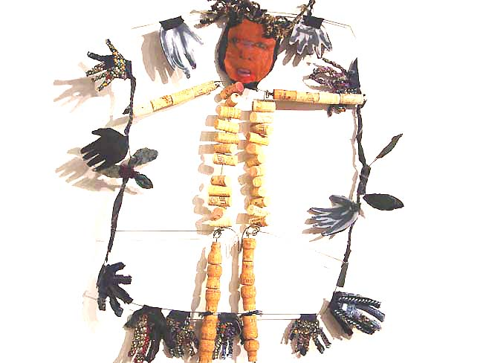
Marita Dingus, Cork Figure

Rarely is one so immediately aware of the particular power of artists to transform the ordinary into the extraordinary as in the work of Marita Dingus. An 18 foot Woman as Creator entirely made from scraps of used fabric and thrown away materials hovered from the ceiling of her recent exhibition “Talking With the Dead” (Francine Seders Gallery May 2 – June 1). Suspended in a network of wire/fabric branches and leaves, the figure’s center of energy is a naturalistic face painted in oil on canvas and oversize collaged fabric hands and feet. The pairing of a realistically painted face with a body constructed of the rejected scraps of our society is a powerful formula that Dingus uses in all of her figurative work. This large woman’s face suggests an inner focus, her energy flowing from another realm. She is both growing new life and hovering over death, black flowers lie on the ground as delicate green stems reach upward.
The title works of “Talking with the Dead” playfully combine white wire skeletons and flat black fabric phones. These telephones are old; they have buttons that indicate their rotary dials. The conversation seems to be from another era and the use of Calaveras type skeletons (those exuberant Mexican escorts) makes it a conversation across cultures as well as across time and beyond the grave. But this is simply an amusingly literal reference that underscores the point of the show.
The whole show is actually a conversation with the dead, more specifically dead African Americans slaves. Dingus has frequently worked with references to the history of slavery and its brutality as well as to African spirituality. It was specifically depicted in a recent work acquired by the Seattle Art Museum called 400 Men of African Descent (1994) in which the artist made 400 twelve inch men with no heads as a reference to the 400 men packed into cells before they were shipped off as slaves from Ghana. In “Talking with the Dead” the references are more compressed and oblique. The large Creator figure generates life and death, but the various other figures bear the strains of a history of physical and spiritual suffering, lack of freedom, or hidden anxieties. These figures are made of pull tabs, corks, test tubes, plastic, wire, fabric with faces painted in what passes for realism in Western art traditions.
The tangled lines of the figures, the compressed organs created with string and wires winding like intestines inside screens at the center of bodies, the blood red figure subtitled “as if it rained blood” that uses a shiny red fabric, all speak of bodily and spiritual pain. Fabric Figure with Caution Markers is framed by black and yellow plastic caution tape, the type of tape you can’t cross in the street. The metaphor seems clear, this black man can’t cross, and he is trapped by the tape. Two foot figures built up in segments from corks are trapped in frames of hands, helplessly unable to resist invisible forces that have given them only a small space of their own. Beings Transparent made of small test tubes are only one foot high and suggest people who have reduced themselves to the point of near invisibility. You can see right though them except for their faces and hats. Other figures of only woven “vines” seem to have recreated themselves in consonance with the Woman as Creator.
It is so easy to go wrong using throw away junk. It is also easy to miscarry on spirituality. But re-using scraps of fabric is an African American tradition and Dingus taps into ancestral African energy in a way that fills all the works with a powerful presence. Her used materials become a metaphor for the recovery of the humanity and dignity of African Americans not only in the past but also in the present.

