EXHIBITION REVIEW
“Seattle: Mary Henry”
©Susan Platt first published in Art Papers, 2002
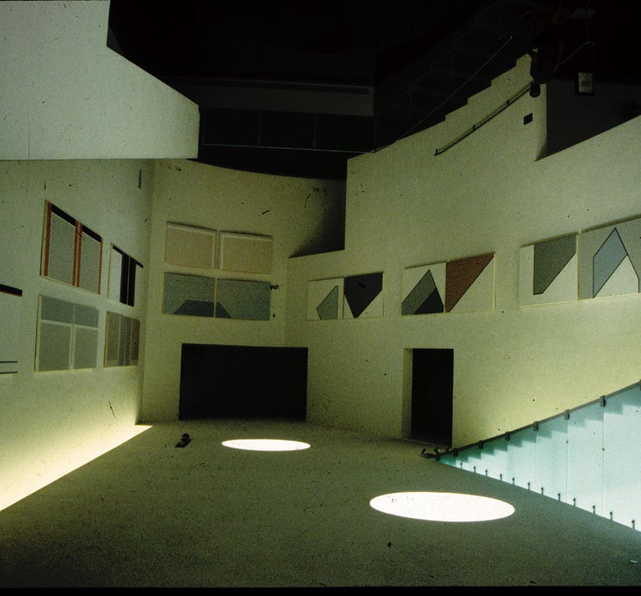.
©Susan Platt
Mary Henry: Bellevue Art Museum Installation North Slope Series
Mary Henry’s abstract paintings (“Modern Master Works,” Bryan Ohno Gallery, Seattle July 5 – July 28) are rooted in a direct knowledge of Bauhaus and Constructivist principles. Eighty-eight year old Henry studied with Laszlo Moholy-Nagy at the Institute of Design in Chicago in 1945 –1946, the last year of his life. She was the only student during that year with an art background (and she had studied industrial drawing which also matched Moholy-Nagy’s principles on combining art and life). At the end of the year, with the program rapidly expanding through the GI bill, Moholy-Nagy even invited Henry to join the faculty. Unfortunately, she was not able to stay in Chicago, and Moholy-Nagy died of leukemia only a few months later.

A photograph of Henry’s own light-space modulator, made from wire rods, string and wood with complex interconnections of space, hangs in her current home and provides a direct link to those student days as well as a demonstration of her knowledge of Bauhaus principles. It moves beyond layered planarity of into a multidimensional world defined by light. Her grasp of Moholy-Nagy’s concept of “vision in motion” gives her work a spatial complexity that contrasts with that of artists who work with the low relief space of cubism or the colored grids of Mondrian. Many American painters (and Clement Greenberg himself) picked up an understanding of abstraction in the late thirties and early forties from Hans Hofmann whose concept of push pull was based on cubism with a dash of expressionism based on Hofmann’s brief early contact with Kandinsky. But Moholy-Nagy believed that “Abstract art creates new types of spatial relationships, new inventions of forms, new visual laws – basic and simple- as the visual counterpart to a more purposeful, cooperative human society.” (The New Vision)

Painted in acrylic on a two dimensional surface, works like Company I, II and III, 1998, give the viewer a visceral experience of color moving in space. The structure in these paintings holds us in a parallel universe. Company I has a large white irregular polygon at its center tracked by a few black lines held by a square of blue with a yellow, orange and purple polygon against a grey background. Company II has a larger white area, with a more dynamic line, deeper orange, blue and red. Company III is denser with large circles of white partly overlaid with gray areas and framed in intense yellow with just a little red in the center. The three paintings seem to carry on an increasingly complex conversation. Other paintings in the exhibition included Still and All, 1997 and The Tagus 1992 and Red Fracture 2001 each one working with different geometric and color relationships. The Tagus has yellow, red and blue squares with a lot of black, Still and All has more diagonals and long verticals and more grays, Red Fracture is black and white with a large circle in red, broken by a stepping white.

Paired with these bright works was a second room of works with more subdued colors and playful geometry. She Bang 2000 is a diptych with bluish gray and white panels that seem to be juggling circles painted in black and white stripes, blue or white. The black and white striped circles recall Henry’s op work from the sixties when she occasionally extended into three dimensions.

The North Slope series at the Bellevue Art Museum (June 30 – September 23, 2001) has a more ascetic, less playful quality. The eleven works (there are a total of twenty two paintings and fifty drawings) are based on the artist’s trip to Alaska in 1975 when she visited a tiny village on the North Slope that was barely accessible to the outside world
(Not surprisingly, it was an oil company which had only recently built a road penetrating this pristine world) The North Slope paintings are all grays and whites with some black. An emphasis on diagonals abstractly invoke the top of mammoth submerged glaciers or impassable mountains. Sometimes there is a pinkish tone inspired by hardy lichen that survives in the far North. In the delicate drawings (not exhibited) the spare geometry and color variables play out on a smaller scale like a highly disciplined musical composition. These are somber, meditative works invoke the clarity and purity of a place barely touched by human life and the loneliness of those who dare to live there.

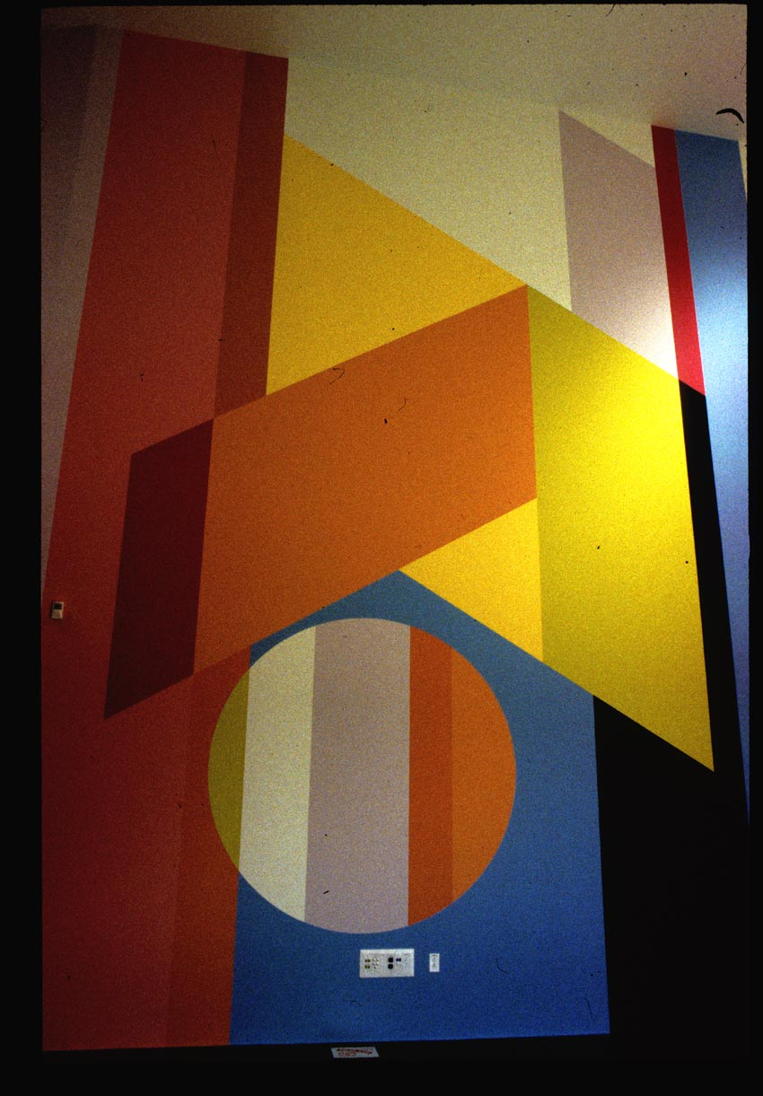
@Susan Platt No Limits Mural(det) Bellevue Art Museum 2002
This summer, in an entirely different spirit, Henry designed an exuberant two story 360 degree mural No Limits in a special projects gallery in the new Bellevue Art Museum. The commission was the inspiration of Brian Wallace, curator at the Museum. Allyn Behr did the actual painting from Henry’s small model. Henry’s ability to organize abstract color in an irregular five sided 360 degree space drew on both her practical experiences as a mural painter in the 1950s and her confident grasp of abstract space and its relationship to real space. The mural has ten colors: yellow, green, violet, three variations on orange, sky blue, alizarin crimson, black, white and a lemony yellow. Anchored by just a few stable floor to ceiling verticals, with large punctuating circles, the composition moves around the room and across corners flawlessly. (You can see it on the Bellevue art museum website). Since the actual walls did not correspond to the architect’s measurement, Henry had to adjust it several inches without throwing off the proportional relationships of the whole. The mural was dedicated on September 20 with an avant-garde electronic musical composition by her son in law, John Rahn . Henry’s mural and her son-in-law’s avant-garde electronic music perfectly suit the new museum’s constructivist inspired architecture by Steven Hull.

In addition to these three shows, twenty eight of Henry’s paintings are on exhibit in the Museum of Northwest Art in La Conner (In the Garden of Myth and Logic, Museum of Northwest Art, October 12 2001 to January 6, 2002), and another exhibition will be held at Lorinda Knight’s Gallery, Spokane, February 2 – 27, 2002.

While each exhibition features a different aspect of the artist’s work, every painting conveys the complexity and flexibility of a purely abstract vocabulary when it is handled by an artist who has studied its theoretical underpinnings rather than simply its formal devices. As Henry has said “I can’t invent things I don’t understand.” While affiliated with the utopianism of early twentieth century abstraction, Henry does not directly speak of a social agenda. Yet there is a feeling of exuberance in viewing these paintings that distinguishes them from abstraction by younger artists whose ironic or postmodern perspectives foreclose any sense of hope. They seem closed and opaque, while Henry’s paintings are full of a transparent joy, a quality in notably short supply these days.

