EXHIBTION REVIEW
“Masami Teraoka "The Culture of the Apocalypse"
©Susan Platt, first published in Art Papers, January February 1997
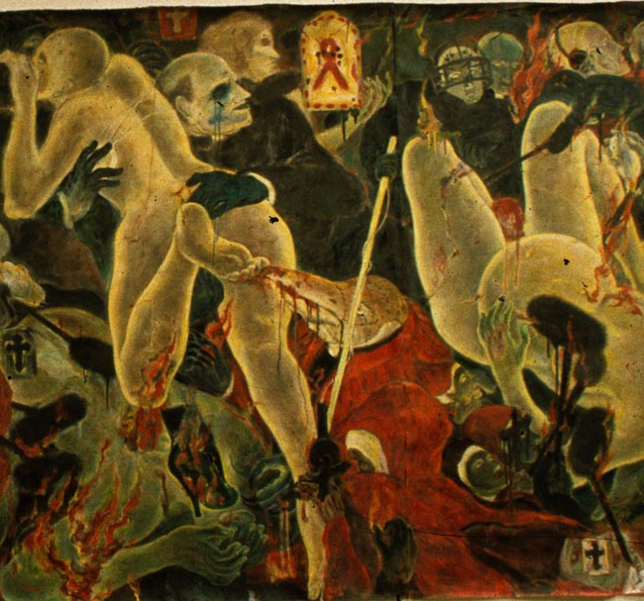
Masami Tereoka Virtual Inquisition/ Reclining Eve, 1997, watercolor on paper, 92-1/2" x 168"(detail photograph by Susan Platt, installation shot) http://www.masamiteraoka.com/index2.html
When powerful corporations decide that culture is good for business, the result is the bounteous hundred day "Sun and Star" celebration held in Dallas this fall. It was sponsored by EDS that's Ross Perot's company), Hitachi and numerous other benefactors most of whom do business between Japan and Texas. Fireworks, art exhibitions, dance, theatre, pageants, and music, educated Texans about this particular Asian country, as well as its contributions to American culture, on many levels. In one afternoon, for example, I went from the familiar ukiyo-e (floating world) of the Japanese courtesan at the Kimbell Art Museum, to the twentieth century "Shores of a Dream" by Japanese American Yasuo Kuniyoshi at the Amon Carter, and the "Big Time" flashing conceptual art of Tatsuo Miyajima at the Fort Worth Museum of Modern Art. High, low, regional, global, native, immigrant, historic and contemporary, it was a provocative juxtaposition.
But there was only one venue that moved beyond the celebratory, and into the disturbing, the McKinney Avenue Contemporary Museum. In their multi-media display called "The Culture of the Apocalypse," Masami Teraoka, looked at the darkness of the contemporary world, architect Shin Tkamatsu projected a chilling, but seductive landscape of computer generated buildings, and Sen Arimura, Japanese comic book artist, targeted political corruption through the lives of migrant workers (burakumin).
Of the three exhibitions at the MAC, it is Masami Teraoka's "Confessional Series, " (parts of which were also on display at the Barry Whistler gallery) that most directly presents our current global crises. In these paintings Teraoka moves away from his now familiar quotation of the two dimensional ukioy-e style. While the artist still works with watercolor
( combined on occasion with oil) to create consummate surfaces, the voluminous figures are now firmly three dimensional, and more cousin to Botticelli than to the black outlines of the ukiyo'e. "The Confessional Series" looks as much to Bosch, Cranach and Ensor, as to Utagawa Kunisada, a garish ukiyo-e master that Teraoka prefers to the elegant Hiroshige. While overtones of the raunchy Kabuki theatre tradition are still obvious, as is the seductive curvilinearity of Japanese art, these new works bridge East and West.
But this technical skill is used in the service of a compelling invocation of the contemporary world crises on many levels. The theme is the intersection of the confessional forum of daytime talk shows in which anyone can parade their traumas to an audience of millions and the catholic confessional, in which only the priest hears the lurid dramas of people's lives. Most of the confessional series are tall panels depicting ghastly betrayals of intimacy. In the Confessional Series, Vampire Bat, the bats parallel the repulsive, invasive monster priest praying (preying) on the woman's body. There is a not surprising reference in two panels to Lorena Bobbitt ( Woman and Haunting Mushroom, Woman with Knife) , and several of the women have huge penises ( a reference, the artist said to what is possible with sex change surgery). The female nudes glow around their edges almost as though they are radioactive. But these women are more often helpless victim than powerful goddess. The desperate horny men in various guises, Adam, Death, the artist himself, and the priest, fondle and violate them. When I first saw this series I was appalled with the depicted violence and felt it was simply another man acting out his fantasy. But these aggressive travesties of intimacy speak bravely to the horrible betrayals that are the constant fare of news and talk show forums.
It was two other paintings in the exhibition, however, that make the new show such an important and radical departure for the artist. While single panels of the confessional series are disturbing, the mural scaled works, particularly the Garden of E Mail and Uluru Web Site, both of 1996, are staggering. The global themes of the epidemic of AIDS and internet culture become a joined dance of death. The setting is the landscape of the eerie, sacred Ayers Rock and its surrounding desert in Australia. In this huge arena several Eve (or Venus) figures dance on flaming computer monitors held by nuns and priests, partnered or pursued by grasping skeletal figures of death, or other priests bearing more flaming monitors on their backs, and aboriginal men holding sacred staffs. A huge serpent winds through the chaos. The dancers are all caught in a tangle of computer cables and mouses that dangle from them like jewelry or fruit garlands. This is a garden of death, with delight as its prelude. Teraoka sees the internet culture as an addictive plague that parallels AIDS in its intense invasive power over humanity, if not in its certain result in death.
The question is are these paintings simply a variation on the theme of violence against women, or are they a protest. Unquestionable, they are intended as a declaration of global plagues of our contemporary society. At the same time though, seeing them as a woman, I myself felt clawed and violated, invaded and terrified. In their intensity and confrontation they participate in the culture that they are commenting on, as much as they expose it. They are irrevocably the product of a male eye. Women rarely have any power, and when they do, that power centers around a penis. Sometimes they are being consumed by flames from the crotch. At the same time the paintings' complexity (the Garden of E-mail is actually a construction, with a real mouse added to connect it to us directly) , their incredibly wide range of art historical references, their global themes make them compelling, and unavoidable. They are the best work I have ever seen by Teraoka. These works do not exist in an aesthetic place, but in a political place. They are contemporary and historic. They are global. They transcend nationality and speak to the world, even as they come out of Teraoka's particular cultural position, as an artist born and trained in Japan and now a naturalized American citizen. He sees the crises from his own experience, even as he sees all of us in it together. I' m not sure Sun and Star meant for this message to emerge from such a brilliant, optimistic festival.

