EXHIBITION REVIEW
“Bellevue (Roger Shimomura”
©Susan Platt, first published Art Papers July August 2002
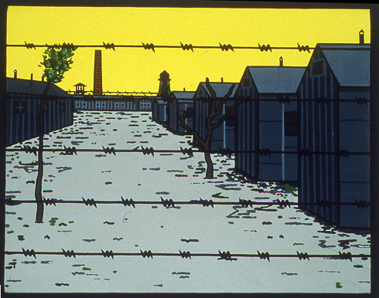
Roger Shimomura American Diary August 17, 1942 ©Roger Shimomura

The Japanese bombed Pearl Harbor on December 7, 1941, when Roger Shimomura was two years old. Along with almost 13,000 other persons of Japanese ancestry from Washington State, his family was forced to evacuate first to Puyallup State Fair Grounds, then in August 1942, to Minidoka, a specially constructed internment camp near Hunt, Idaho.
Roger Shimomura: An American Diary (1997), recently on display at the Bellevue Art Museum, combines quotes from the diaries that his grandmother, Toku Shimomura, kept throughout the experience of the camps, with highly distilled visual images. Shimomura has addressed this theme earlier in his career in various formats, but he decided that for this presentation he would eliminate his usual style of quoting from brilliantly colored and rhythmically stylized Ukiyoe prints. Instead he used simplified shapes, and colors, along with a few of his favorite comic-book characters, notably Superman and Dick Tracy, who here signify American authority and power.
The result is deeply moving. In the representation of his grandmother listening to the radio on Pearl Harbor Day, for example, the 1980 version uses sweeping lines to describe a traditionally dressed Japanese woman dramatically expressing anguish, a purple radio in the background. In the new version, a middle-aged woman in an American style dress stands behind a radio at a window, inside a brick building. The woman is half hidden by the grid of the window, already implying a prison, and the radio becomes an alien intruder. At the same time, the sense of impending, rather than actual, doom is made more powerful by the absence of gesture and movement. The stillness of the image is a forecast of the stasis of the camps, whose main characteristic for Toku, active professional women all her life, was boredom. The image and the text display the same emotional compression.
Altogether there are 30 paintings in the Diary series, and 10 lithographs in Memories of Childhood (1999) based on the artist’s own recollections such as quarantine for chicken pox, the lines for the bathroom, the visit of a friend from Seattle. In both series, simplified images of unfamiliar American food like hotdogs and bologna, barbed wire, walls, and houses are combined with references to rituals associated with the continuation of life, as in Roger’s birthday party and the birth of his sister (who died at the age of 2). Many images refer to the day-to-day discomfort of performing the most ordinary task with weather as a constant refrain. Paired with his grandmother’s comment on the frozen, muddy roads, is a representation of legs in Japanese style high wooden slippers walking across treacherous ruts.
As a response to his concern that young Japanese Americans are tired of hearing about the camps, Shimomura created the performance piece Amnesia, which accompanied the exhibition in Bellevue. Using an eclectic and intentionally distracting collage of an opera diva singing an aria from Madame Butterfly, karaoke singing, train sounds, bird sounds, images of barbed wire, a video of a Chinese skateboarder visiting the Manzanar camp, the performers enacted the starkness of camp life through repeated actions like hanging laundry.
Selected Works, a third part of the exhibition, reveals Shimomura’s dry humor in dolls with labels like “Minidoka Tourist,” and the collages “110 Misspellings of my Name,” and “ 24 People for Whom I have been Mistaken.” The monumental “Sansei Story,” (1990) is a virtual compendium of Shimomura’s vocabulary, with quotes from comic books, pop art, and movies, as well as references to assimilation, surveillance, and the fantasies of the American life style. It includes seventy-six small images some of which (barbed wire, hotdogs) found their way into the diary series. At the center, jumbled inside a large washing machine, are Superman outfits, American clothes, and Japanese clothes. The artist carefully chose these supplemental works in order to provide context for the images of the camps. They reveal the chaotic movie-like character of assimilation as well as mainstream America’s ignorance about Asian culture in general. In the distilled images of An American Diary, Shimomura makes the devastating results of that ignorance impossible to misunderstand.

