CATALOG ESSAY
Selma Waldman
in Selma Waldman/Naked/Aggression: Profile of the Armed Perpetrator 1998- 2003
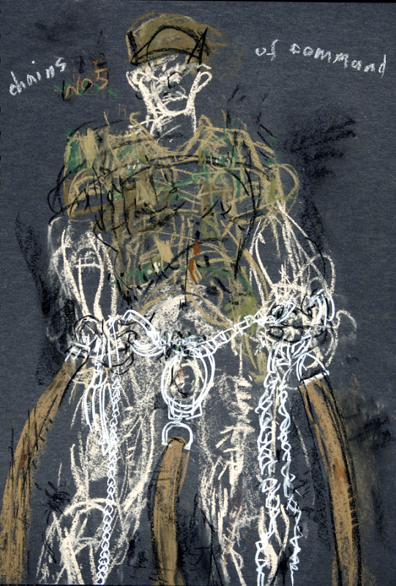
Selma Waldman, Chains of Command, pastel on black paper

“Lust for power and territory is the same lust that kills man, women, children and the land itself” Selma Waldman 2002

Selma Waldman explores the relationship of war and sex. Two small three letter words that both drive powerful forces in the world. When you put them together you have a lethal combination. Literally.

Waldman’s drawings are seductive: they invite us in with their sensual drawing. She often works in charcoal because she believes that the fragility of charcoal parallels the fragility of human life. It is strong and resilient, yet easily crushed. . In her commitment to line and drawing as the basis for her art, she is consciously working in the tradition of the great German artist Kathe Kollwitz, whose career was also spent in protesting the injustices of war in graphic form. Waldman’s charcoal drawings unrelentingly confront the seductive power of war, the perpetrators of war, the addiction of war and its physical, sexual energy. In her sketchbook of combatants, each soldier is formed from a continuous web of lines, the phallic gun and the soldier’s male organ forming a partnership, as they do in war

She began a small scale drawing series in October 1998 called the Book of Combatants: her combatants are naked below the waist; sometimes they carry a cigarette, sometimes they are overwhelmed by the size of their armament. Usually the works have a dominant red, associated with both passion and death. The Book of Combatants is part of the series “Naked Aggression” that the artist began in 1989 during the first intifada in Palestine. Many of the source images come from the newspaper. For this exhibition she has framed the works individually to make a Wall of Perpetrators. Naked Aggression is itself part of a larger series called The Altars of Fear.

Waldman enlarged some of the small drawings. She works in gesso on paper, with charcoal and colored pencils, sometimes adding acrylic on top. Naked Child’s Play shows just the upper two thirds of the body, and half of that is naked. The vulnerability of the naked body is contrasted with the warrior’s garb, even as the whole drawing is stitched together by the threads of violence which animate it.

The acid-green “Blow Your Head Off!” is based on an actual incident. A journalist in Kosovo was driving across a checkpoint from Zagreb to Kosovo. His companions were shot. He survived, after the guards played a game by putting a gun in his mouth and withdrawing it. Waldman has made the connection to the sexuality of this game obvious. The image is blatant, also unusual, the male organ is the central focus of the drawing.

Riot Man: Naked Cover is a long large painting of faceless riot police in front of a nameless city. They are dehumanized warriors, who advance toward us without any understanding of the humanity they are about to slaughter.
Usually, as in Goya’s Disasters of War, all the combatants in Waldman’s drawings are equally violent. Waldman’s all encompassing theme the “altars of fear” implies the presence of the victims of aggression in all its forms, but also of course the fears of the combatants who act out of their own fears to kill, rape, mame, and terrify.

Waldman has dedicated her life to exposing this dark world.

