EXHIBITION REVIEW
“Lucienne Bloch: A Retrospective”
Mendocino Art Center Mendocino California August 3-31, 1998
©Susan Platt first published Art Papers Magazine, January February 1999

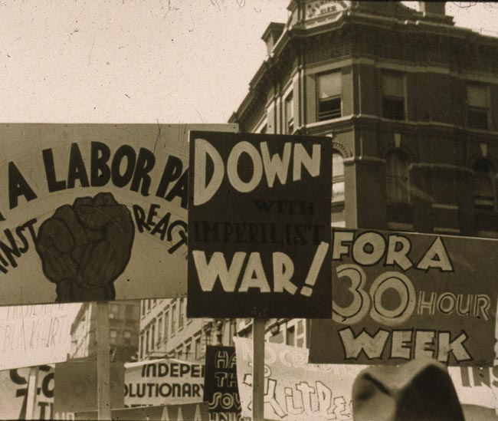

©Lucienne Bloch, photograph of Demonstration in New York City, 1934
At a time when she had been living with Diego Rivera and Frida Kahlo for about six months, Lucienne Bloch wrote in her diary in August 1932: http://www.luciennebloch.com/index.html

"We took cold chicken in a little basket and went to Belle Isle dragging Diego with us at the last instant. It did him good to go out. He was so surprised at the beauty of the trees when lying down in the grass. He says trees are ugly and nature is hokum, but he can't help admiring it when he's in it."

Her informal photograph paired with this amusing remark, one of the many surprises of her recent retrospective, shows Rivera lying exhausted on the ground with Frida Kahlo seated nearby. Taken in Belle Isle, Michigan, shortly after Kahlo's painful miscarriage, the photograph documents a rare moment of relaxation for this very public couple. It includes Bloch, by implication, in the intimate family circle.

During the next months, Rivera would complete work on his huge cycle of murals called Detroit Industry, then go on to the disastrous Rockefeller Center project, where his Man at the Crossroads would be censured because it had a portrait of Lenin. Bloch assisted Rivera on both murals, accompanied Frida on a trip to Mexico, and took the only surviving photographs of the Rockefeller Center mural after the work was halted. But Lucienne Bloch's career was about much more than her friendship with these two famous artists. The retrospective made clear that Lucienne Bloch is a significant artist in her own right in a wide range of media: etchings, sculpture in glass and wood, oil paintings, ink drawings, wood cuts, wood engravings, and lithographs. It establishes that she was an extraordinary photographer, but that, above all, she went on from Diego's training in fresco to collaborate with her husband, Stephen Pope Dimitroff (who was also Rivera's assistant and occasional model) on almost fifty fresco murals. Dimitroff prepared the walls and Lucienne painted the imagery. The two also worked as a team in giving workshops on the complexities of classical "fresco buono."

In the exhibition in Mendocino, it was difficult to convey Bloch's huge output in fresco, since all the works are in situ, but the show did feature some fragments and studies. It includes all of Bloch's glass sculpture from the 1920s, made at the Royal Leerdam Factory in Holland, which led Frank Lloyd Wright to invite her to teach sculpture at Taliesin East. Bloch took him up on the offer, but was disenchanted with Taliesin after only a week, and went to work for Rivera instead. Bloch came to art in part through the encouragement of her famous father, Ernest Bloch, a Jewish-Swiss composer and photographer, who taught her how to develop photographs when she was ten years old and gave her a Leica in 1927.

In the 1920s she had academic training in Paris, but even then sought out strike scenes. She took modernist photographs of New York (she was also friends with Alfred Stieglitz), but quickly turned to more socially-engaged topics like the artist/worker May Day marches. She not only took photographs, she marched, made posters, lettered signs, and drew huge, outrageous caricatures.

Bloch went on from artist-worker strikes to photograph the early days of the unionization of auto workers in New Jersey, New York, and Michigan, partly as a result of her husband's work as a shop organizer. She made photographs, sometimes on assignment for Life, of historic moments like the Cadillac Square Demonstration in Detroit in 1937.

For the retrospective, Lucienne Allen, the artist's granddaughter and curator of the exhibition, found quotes from her grandmother's diaries to accompany almost every work. The result was a startling layering between the art object, the collective and public moment in which the piece was made, and the very private responses of one individual who was both a participant and observer. Much of the art came directly from the artist's family of whom five generations attended the opening. The artist herself was also there, almost ninety years old, and talking informally about her work.

Bloch has spoken out without any hesitation throughout her life. Under her serene and self-effacing demeanor is a person who has always cared as passionately about the state of the world as about the aesthetics and techniques of art. One of her woodcuts appeared on the cover of Songs of Protest by Pete Seeger during the McCarthy era. In 1966, she commented on her spiky drawing called Redwood Cemetery that "Man needs to build armaments so that he can feel powerful. He also needs to destroy nature so that he feels powerful." Her recent oil painting, View from my Porch, (1998) still suggests, in its carefully observed details, the vulnerability of nature. Even the fresco workshops made a statement. Fresco is a collaborative art that speaks to the public directly. It is the antithesis of the individualism usually taught in art schools, and counters the idea that the goal of art is the creation of objects to sell. As she and Stephen Dimitroff taught fresco techniques at universities throughout the country, they never ceased to pair their love for the technical complexities of "fresco buono" with a political message about public art and collaboration.

Stephen Dimitroff died in 1996 so he was present only in spirit at the opening of the retrospective exhibition, but the show itself documented the rare phenomena of a lifelong commitment to both art and social concern.

