LECTURE
“Art and Activism Then and Now”
©Susan Platt presented at the College Art Association, Chicago, March 1, 2001

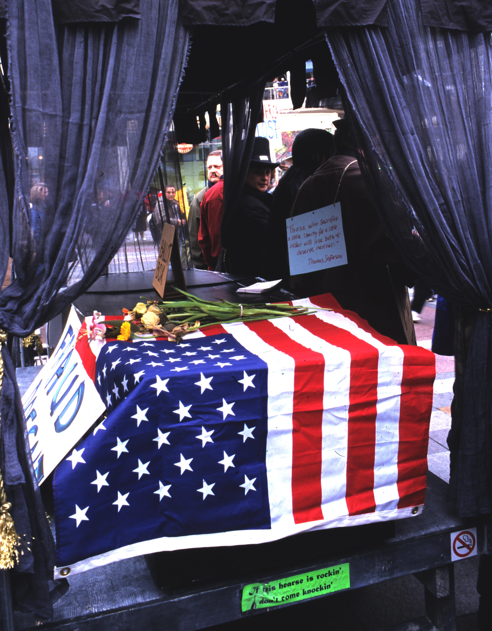

The intersections of art, politics and activism are now possible through the click of a link on a website. These connections are beyond the wildest dreams of the Communist party as it struggled to create a world revolution in the early part of this century. While it had a vision of linking workers around the world, it did not have the technology to make those links. The thousands of people protesting the IMF, WTO and World Bank around the world are testimony to the fact that the internet is providing a phenomenal new means of communication that is leading directly to action. Individual artists and artists groups are now collaborating with a broad spectrum of unionized workers, environmental groups, and political organizations in the outpouring of protest against global capitalism.

Activist, multi-issue demonstrations in which artists, workers and political groups join forces have direct antecedents in the 1930s when similar coalitions emerged to protest capitalist exploitation and Fascism as well as to demand jobs, better working conditions and an end to economic slavery and police brutality. Artists joined in all of these causes. Today, I will contrast the activism of the thirties with some examples of activism today among artists, concluding with the coalitions that have formed in conjunction with the WTO protests that emerged in the fall of 1999 in Seattle as well as more recently.

During the early Depression years, particularly from 1930 to 1933, the economic crises undermined the traditional support for culture. Galleries were unable to sell work; collectors were unable to buy it. Art related jobs vanished. Artists found themselves literally forced out into the street. As the situation became worse, they increasingly surrendered their isolated bohemian role and began identifying with other unemployed workers in political groups. Artists began to assert their power collectively, first to protest the oppressions and failures of capitalism, and then to oppose the spread of totalitarianism and fascism. Artists like Ben Shahn and Lucienne Bloch photographed the artists’ demonstrations at the same time that they participated in them. In Bloch's case she was also photographing the signs that she had made, with the support of labor unions. In these demonstrations you see artists organized in protest and in support of economic issues shared with all unemployed workers, pay, jobs, unions. And these were not superficial commitments. Lee Krasner has described being in every jail in New York City during these years.

These actions were a manifestation of Proletarianism, a campaign supported by the Communist Party that included both workers and intellectuals. In the leading proletarian publication, New Masses, expressionist prints, fiction, poetry and critical theory created a collective political stance that came from and led directly into the street. New Masses workers art column served as a call to arms and a bulletin board of activities for events like Hallie Flanagan's experimental theater that addressed the suffering of dust bowl farmers. The comparable locus for collaborative work today is the artists' group "Art and Revolution," which is linked with the website of independent media "Indy media." The obvious difference is that today these collaborations are usually independent of a single political party's control, although Democrats, Anarchists, Socialists and Communists all join with these protestors and support the same causes.

The John Reed Club named for the revolutionary journalist who wrote Ten Days that Shook the World, was intended to "train students to take a practical and active part in the development of an art which will advance the interests of the working class." As one announcement explained "John Reed Club artists have organized a poster group with the aim of making posters in black and white as well as in color on themes of a strictly contemporary proletarian, revolutionary character (anti-militarism, anti-lynching, economic exploitation etc.) These posters in 2 or 3 uniform sizes will be offered to Worker's Groups and organizations which can use them to decorate club rooms to advertise meetings, to illustrate courses of study, to give away as prizes. Etc."

The Club affiliated with the International Union of Revolutionary Writers in 1930. Artists depicted subjects such as the abuse of miners by capitalists, lynching, injustice against blacks by police. Using Goya, Kollwitz and Orozco as points of departure, a visual artist like William Gropper wrote an illustrated "Letter from a Coal Field," Elizabeth Olds and Mabel Dwight made satirical lithographs about the disintegration of capitalism, Bernarda Bryson produced etchings on the arrogance of the dispensers of home relief, and Walter Quirt dramatized racial and political injustice.

Recognized martyrs represented the suffering of hundreds of others who were unknown. In the 1930s those martyrs included Sacco and Vanzetti as well as Tom Mooney and the Scottsboro brothers, eight African American boys who were accused of raping two white girls. Through the defense team of the Communist Party they were found innocent. Today the famous martyrs are Mumia Abu Jamal, the African American on death row who has been accused of killing a police officer and Leonard Peltier, a Native American who was framed by the FBI for the death of an agent and has been in jail since 1976.

The Proletarian movement also included artists like Tina Modotti who was based in Mexico and recording the protests against capitalism there in the late 1920s. Modotti learned photography from Edward Weston, but was also a firm participant in the Communist Party. Her work was featured on the front pages of New Masses as in The Striking Mining Worker's Wife. Proletarianism was linked to political action on every level. The artistic production, which ideally was produced by workers as well as trained artists, was in the service of a larger cause, and was frequently used in demonstrations, handed out for free in inexpensive prints, or painted on public walls.

In 1933 activism among artists expanded to a much larger scale as a result of the censoring of Diego Rivera's mural Man at the Crossroads in Rockefeller Center in May 1933. It was a collision of capitalism and Communism, triggered by the fear that Rivera's portrait of Lenin in the mural would discourage businessmen from leasing space in the building. After the actual destruction of Rivera's mural in February 1934, thousands of artists organized protests to condemn the censorship with public demonstrations and protests. This issue of censorship appealed to all the artists whether academic or communist, and spurred a much larger coalition that would form the basis for the American Artists Congress.

Key to the success of these politicized actions was the support of critics like Anita Brenner and Elizabeth McCausland, who wrote lengthy newspaper columns in support of the artists. Brenner had formed her revolutionary opinions in Mexico during the early 1920s when she found herself at the heart of the Mexican mural renaissance following the Mexican revolution, when artists served the revolution with public murals and prints, as well as educational programs that taught art to peasants in villages as part of a literacy campaign. She took up her pen in the New York Times in defense of Rivera: “By a strange coincidence, at dawn of the day when Hitler was having Germany purged of everything Marxist, modern, and Jewish in its literature, the Rivera murals at Radio City were nailed into what may turn out to be a coffin."

Elizabeth McCausland had covered labor strike stories in Massachusetts, as well as the arts. She was ideally suited to support the new radicalism among artists. When she attended the American Artists Congress of February 1936, she joined 400 other artists and critics. The Congress marked a high point of collaborative activism among artists in the 1930s. Its purpose was primarily to oppose fascism both in Germany and the United States. The specific resolutions passed consisted of boycotting the German Olympics, supporting the banned Sinclair Lewis' movie It Can't Happen Here, and opposition to sending artists to CCC camps, known as rallying grounds for Fascism, as well as protesting the imprisonment of people fighting for civil rights in Brazil and Cuba, and opposition to Italy's invasion of Ethiopia. The Congress also published a Bulletin and organized exhibitions, some members volunteered to fight in the Spanish Civil War in the Abraham Lincoln Brigade. The Congress first brought Guernica to New York where it remained on exhibition until 1975 at the Museum of Modern Art.

McCausland reviewed all of these activities at length in her newspaper column. In one of her first columns on this subject she declared: "The American Artists Congress marked the dramatic end of a period of isolation and the beginning of a period of "collective solidarity"… In the real world into which the artist was forced by the economic crisis, the artist is now beginning to face the realities of life. American artists are awakening to the urgencies of the times. They are seeing their work destroyed by intolerant and censorious groups. They have had their economic security snatched away from them. They have had to fight for a bare minimum of consideration in the government relief programs. And so they have come to understand that politics is something of vital concern to every citizen. In fact they have even read the Declaration of Independence and the Constitution. For the first time in history, American artists are acting as well as talking."

At the same time, as mentioned in McCausland's review, the Federal Government was sponsoring artists with relief programs that paid them an hourly wage as workers. These programs led to the production of murals, prints, and other types of socially based art. While the imagery of the government sponsored art was far less radical, the activist artists continued in the context of the government sponsorship to work collaboratively and to identify with workers issues, to unionize, to strike and to protest when their jobs were terminated.

Almost all of this collaborative political and social concern on the part of intellectuals and visual artists came to an end in the late 1940s. With the attacks of the Un-American Activities Committee escalating, political activism was suspect. As congressmen rifled through old copies of New Masses, artists retreated into abstraction. 57th St became the new center for the art world, and capitalism returned, along with an emphasis on heroic individualism as exemplified in the work of Jackson Pollock.

It was only in the late sixties that activism began to re-emerge again among artists, inspired by the tactics of the Civil Rights Movement. As recounted in Get the Message by Lucy Lippard, the Art Workers Coalition emerged in 1968 to 1971 declaring that "art is manipulated by greed, money and power." AWC and other groups focused on support for peace, opposition to government policies, and more locally the abuse of power of the Museum of Modern Art. Even as Lippard published her book, activism and political awareness was escalating. Coalitions formed to protest the nuclear bomb, following the movie The Day After. Nina Felshin's exhibition, Art of the Apocalypse, toured the country. At the same time, the great tragedy of HIV-AIDS directly struck at the art world, killing many of its outstanding young artists and resulting in an outpouring of protest, visual art, theater, poetry, writing, and community activism that is still on-going.

PART II Art, Activism and the INTERNET
THE WTO, IMF, WORLD BANK DEMONSTRATIONS

The number of artists currently involved with social, political and economic issues is exploding and their impact is expanding in two ways, first through the internet, and second through public multi-issue protests in the street. Both types of expansion are crucial. Viewing a website by a single artist does not change the world. Marching for one issue has little impact. Through the linked networking of cyberspace, we now have communication across issues and among individuals. We have a collective voice from traditionally more elitist artists and popular artists. These massive protests are paired with art in many media: performance, video, cartoons, street theater, poetry, photography, collage. Those street expressions reinforce and activate the more academic art that addresses environmental concerns, labor and union concerns, health issues, racism, war, refugees, immigration, human rights. Art that addresses these issues can be found on the web along with massive amounts of information. Actually though all of these issues are part of globalization as is the massively bankrolled American election process, an event that got even armchair liberals into the street with pungent protest signs.

In the context of the WTO, many types of artists responded directly to the demonstrations. Dean Wong, an award-winning Chinese American artist has spent his career primarily photographing his own community within Seattle, the International District where he grew up. This district is a distinct community of many different Asian groups. At this time the property values are soaring because of two new sports stadiums that have replaced the King Dome. When Wong went down to the WTO protests and recorded the dramatic confrontations, he went as an artist, drawn to record the event, not as a political activist, nor as a reporter for his community, yet the global forces that the demonstrators were protesting, are certainly directly threatening his own community. His dramatic photographs record the actions by the demonstrators who were preventing delegates from entering the convention center, as well as the response by the police. In Wong's work there is a sense of the importance of community within the action, as well as the individual within that community.

Allan Sekula came to Seattle from Los Angeles to photograph the WTO. His photographs are included in the book Five Days that Shook the World by Alexander Cockburn. Sekula's photographs contrast with Wong's. They focus on individual emotions, rather than community, on brilliant color and aesthetics, more than on the dramas and tensions of the crowds. Sekula has been involved with global politics before, most recently in his series on the abuses of international maritime trade.

Another artist who made memorable photographs of the WTO is a young, recent graduate of the University of Washington, Michael Barkin. Barkin's photographs are dramatic in their confrontations with the forces of oppression. He includes both individuals and is a socially committed artist who has also traveled to Mexico to record cooperative coffee farming.

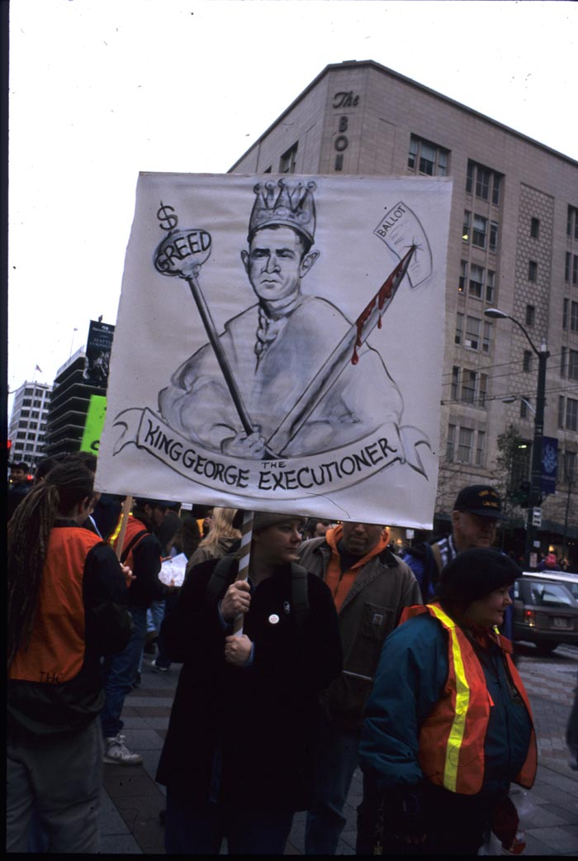

Following the WTO demonstrations, the Center on Contemporary Art in Seattle held an exhibition in conjunction with two media groups called "The Whole World is Watching, Art, Literature and Images from the WTO Protests” that included a Democracy Wall in the gallery where anyone could add comments. One of the works included was by Deborah Lawrence, who has repeatedly engaged with political issues in her collages, through her fictional character DeeDee Lorenzo. Dee Dee has attended many of the demonstrations over the last thirty years in Seattle. Collectively these works form a remarkable record of protest. All of these artists have a commitment to engagement with social issues. Yet, the impact of their work is greatly enhanced, as is the impact of the protests against the WTO, by the internet connections which continue to promote opposition to globalism.

As in the thirties in New York when dozens of artists were repeatedly arrested as they demonstrated for workers causes, today artists are also being arrested, perceived as a great threat. For example the puppet making group "Art and Revolution" began a few years ago to develop political art in workshops for one day events. Now it is producing puppets that are part of the multi-issue protest marches against the WTO and other issues such as the American elections.

The statement on their website declares "we emphasize politics and direct action. We see activism as crucial to meaningful arts expression. We believe that our politics suffers without creativity, in the same way that our art suffers without political or social dimensions." But, as they become more politically engaged, they become more vulnerable. One branch of the group in Philadelphia was making a float called Corpzilla, the Corporate Monster and a ten foot skeleton puppets for each of the 138 people that George W. Bush had executed in Texas, as well as cockroaches(who clean up after a mess), mice (who scare elephants), peanuts (the food of elephants), inscribed with corporate contributors. They were handcuffed and left in a bus without water for ten and a half hours, for six of which they had no water and for the entire time no access to bathrooms. In police custody, they continued to be subjected to abuse such as kicking, hitting their heads against a wall, and being beaten unconscious. All of their puppets were destroyed by the police, as well as all of the possessions that they had in their workplace, in preparation for the Republican National Convention. As one of the victims of this horrifying episode wrote: If protesting against perceived injustice warrants arrest, if just the very act of saying "no" to any status quo you feel doesn't represent the people is criminal behavior, if making art in a privately owned building is cause for punishment, if civil disobedience justifies an ever escalating level of brutality, … then a serious reexamination of where this country has gone needs to get under way. (Dave Bailey, Subversive Criminal Puppeteers, Media Reader, Jan, Feb, Mar, 2001, pp. 10 - 11) As the level of police brutality increases in response to specifically the artists who are in the street, it demonstrates the huge power of visual art in the context of political struggle as well as the huge need for visual artists who are willing to get into the street and out of the safe spaces of the art world.

As another example of that I would like to now show a few minutes of the video. This is What Democracy Looks Like based on the WTO demonstrations last year. It is put together by Independent Media, a collection of independent media organizations and hundreds of journalists offering grassroots, non-corporate coverage. Indy-media is a democratic media outlet for the creation of radical, accurate and passionate telling of the truth."
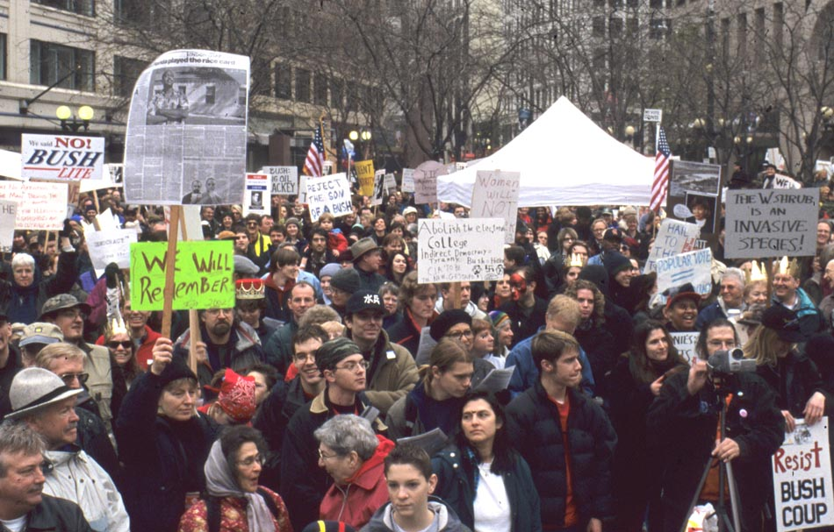
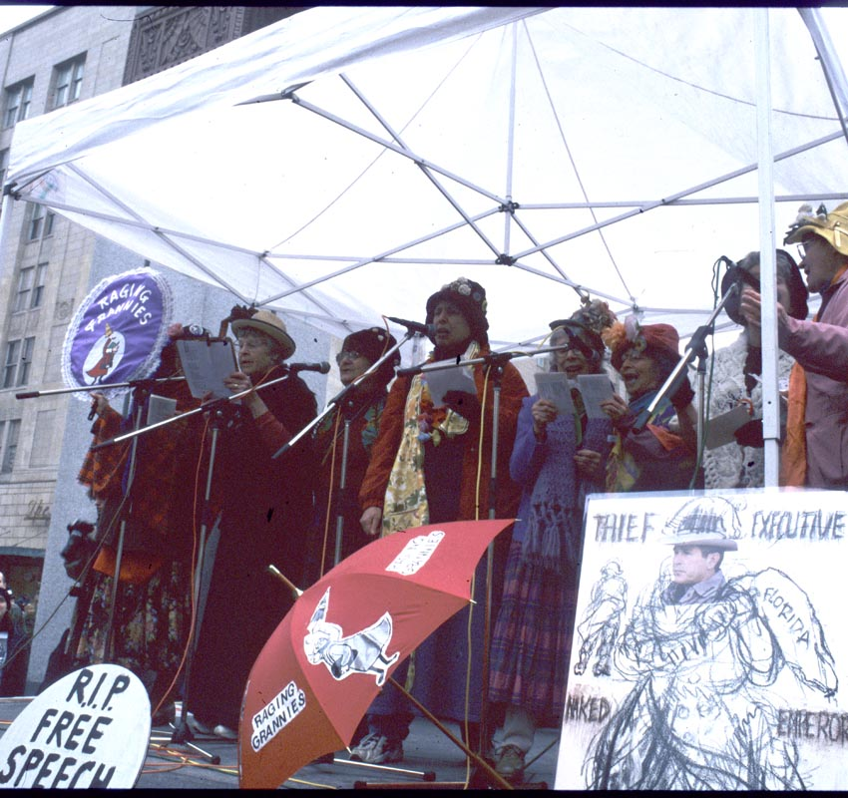
©Susan Platt Raging Grannies and general crowd (Selma Waldman in the foreground) Seattle Washington at Protest of 2000 Election

Collaborative activism that involves artists continues. Around the world there are ongoing protests. On the anniversary of the original protest of the WTO in Seattle there was another protest with some of the same groups, such as the Lesbian Avengers, the Cascadia Art and Revolution puppets (now focusing on Police Brutality) and other groups. There is currently a group forming called Art, Media, Politics which is encouraging collaborative presentations in theater, film, exhibitions, poetry, fiction, music, and performance art in order to have more impact. These types of connections, this new move beyond individualism, I would suggest is a result of the linking that happens on the internet. It is erasing separations of media, separations of street and gallery, separations of individuals. The continuum of street, city, interne, action is dynamic, explosive and powerful. Any one of these components is important, but collectively, it is fueling a world wide opposition.

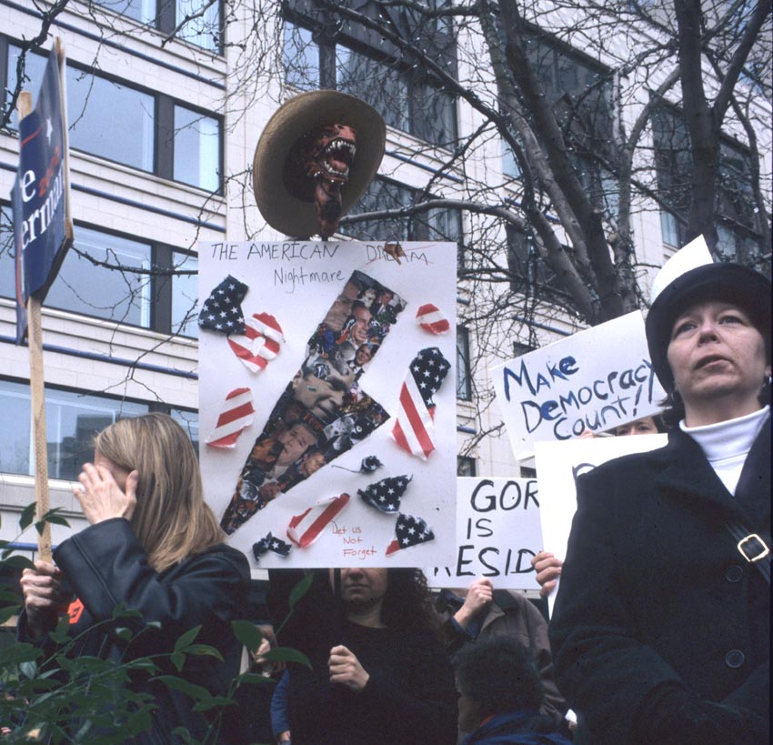

Today's political activism that includes creative artists in all media and is manifested in streets around the world is similar to the outpouring of protests against fascism that came in the 1930s. Creative people today once again realize that they must actively produce art that addresses global atrocities. Collectively they make a difference. The Internet is the most powerful new means of communication since the printing press.

