ESSAY

“Fast Growing Grass Roots” The Art of Resistance Conference, Seattle May 2004
©Susan Platt First published in Raven Chronicles, War Veterans and Peacekeepers, vol. 11, no.2 10-12
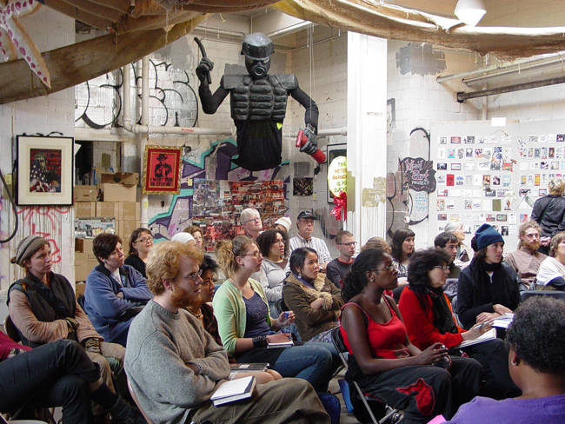
Combining trained artists and grass roots activists, the Art of Resistance conference first took place in Seattle in the spring of 2004. It had roots in prior activist artist groups, but its focus was specific, to create a sense of community for activist artists, a place for exchange of information, training, and celebration in solidarity for resistance to imperialist war. The initial impetus targeted George Bush.

Art of Resistance was a descendent of the anti globalization movement, the anti-war movement and, initially, a desire to produce informational agit prop for the 2004 Presidential election.

The anti –WTO confrontation with global imperialism began with an uprising in Bangalore, India, with half a million Karnataka Farmers resisting a WTO meeting ( p xxxix Confronting Capitalism) , followed by the Zapatistas in 1994 who may have been the first group to use the internet to call attention to their activities all over the world. Opposition to globalization emerged into international super-prominence in Seattle in the fall of 1999 when the WTO talks were actually shut down by demonstrators. . Guerilla art poured into the streets as part of the global economic protest against neo colonialism. Giant Puppets, sea turtles (as part of the environmental protest against lifting of environmental controls), masks of imperialist perpetrators, and a general carnival spirit of individual freedoms and free wheeling expression.

Although the Seattle anti-WTO was violently truncated by the crackdown of the police, the anti-Globalization art movement generated both through the internet and in collective street actions remains today the center of current resistance art.
In Seattle, the spirit of art as activism continues, in the age of Terrorism, to generate the Art of Resistance conference, an annual event organized by a small group of grass roots activists who want to provide workshops and presentations that bring together activist artists from all over the country.
Here is my report on the first conference.

Art of Resistance: Fast Growing Grassroots mid May, Seattle, Washington, 2004:

More than 200 people gathered for the first national “Art of Resistance” Conference in the “Arts Warehouse”. The grimy industrial setting in a partially derelict area south of downtown Seattle had both indoor and outdoor spaces and graffiti covered walls. It was a great setting for an art conference intent on making radical political art. “Art of Resistance” created a model for a new type of revolution: artists as leaders, in speaking out. We were not a diversion from politics, ornamenting another agenda, we were the main event. The grassroots group who organized the conference was a collaborative network of volunteers and donors who became a strong system. Grass spreads wiry roots as it penetrates the earth. It grows slowly, creating a dense impenetrable mat that can be destroyed only with difficulty. “Art of Resistance” created a strong collaborative network of political artists.

“Art of Resistance” advocates art as part of life, but this life is not a mundane life, but a life of resistance, not a domestic life or a ritual life, but a life of revolution, of change, of disruption, of revolt, of anger, of organized no’s. It is not a war, because war is a modernist idea and organized by an out of date power position. Our conference had dispersed and collective energy, no one was “in charge.” Our rambling meetings flowed without rules of order or votes. But we spread our energy and power throughout the spaces and over the walls and out in the streets near the Arts Warehouse. After our conference, everyone took the collective energy with them to spread it through other resistant urban centers.

In our planning sessions we spent no time on theory. We were practical and specific. We did not need to talk about why we were creating a conference. We did not explore theoretically what artists can do in the current world crises. We know what we can do. The power of imagery, poetry, music, theater, spoken word, film, video, photography graphics, and banners is obvious. We also know that artists who are political have already made a break from the conventional academic art world, where art is taught as an activity removed from politics in order to sanctify its aesthetics as a “universal” message. We dismiss this arrogance. We reject the lavish use of materials by individuals to create aesthetic statements. Such art is produced as a commodity for sale in a capitalist art market. Modernist “art for art sake” is escapist decoration that contributes to the ignorance and avoidance of our current situation.
“Art of Resistance” uses inexpensive or recycled materials that purposefully address our current crises. We believe in collaboration, collectivity, and communication. We give our art away for nothing.
The purpose of the conference was to teach techniques, provide an historical context for current political art, and look toward the conventions and convergences coming up in the next six months. We were simply organizing an opportunity for people to network, exchange ideas, get to know each other, and above all, feel the exhilaration of knowing that there are 100s of extraordinary artists deeply engaged in political art.
In addition to our planning meetings, we had fundraisers at clubs, we had a booth at the Fremont Sunday Market where we gave away re-cycled tee shirts with powerful political slogans, and we had a fundraiser in which the history of the draft was presented.
We recruited artists, we recruited donations, and we spread the word with our friends near and far. We made the conference happen with a minimum of capitalism. Most of the organizers didn’t even have cars, much less cell phones. Everything was assembled on a donation and contribution basis as much as possible (with the notable exception of permits, licenses, security and the renting of the venue itself). Our first meeting was in late January, too late for grant applications. Even the entry fee was a sliding scale, so anyone could come.
Our organization was horizontal, no one was considered to be “in charge” of the conference, each person took responsibility for their own area. A core group of artists designed posters, flyers, silk screened political slogans on signs and fabrics, put out a mail art invitation. We asked people to bring art for an exhibition; we networked in search of dancers, performers, bands and poets with political positions. We invited political groups to have tables if they had an artistic aspect to their display. We put art at the center of the program, rather than as decoration for something else. That was our essential goal.

Even up to the last week, we were not sure how it was all going to come together, but by some miracle it did. The technical equipment arrived, the toilets got fixed, a sheetrock wall was built for the art show, the art got installed, the warehouse got decorated, the amazing food donations came rolling in, and lots of people showed up. They came from as far away as Maine, and as close as Capital Hill. Portland, Los Angeles, San Francisco, Minneapolis, Philadelphia, New York City, Boston. There were people of all ages and ethnic backgrounds. We gave everyone three meals on Saturday and Sunday for a voluntary donation.

The conference started with several perspectives on the history of political art starting with the invention of the printing press and continuing to the present, then broke into workshop sessions that included media literacy, rubylith and rubber printmaking, silk-screening, agitprop collage, metal sculpture for activists, organizing a graphics campaign, street theater, theater of the oppressed, street photography, banners, video, giant puppets. There were also sessions given by “Poets against the War” and “Making Dances that Matter” a type of collective choreography, music sessions and web networking. In addition other groups focused on the upcoming political campaigns, such as “The Backbone Campaign” and organizing for protest art at the Democratic and Republican Convention, led by Not in our Name.

While everyone had a different experience, there were several aspects that I found particularly exhilarating. First, I reveled in the sheer energy and synergy of the intersections and conversations at the conference and the dynamism of the venue with its large exhibition of political art. Another high point was the presentation by John Rumbiak, an activist from West Papua, New Guinea, who spoke with eloquent dignity of the brutal campaign to destroy his people-100,000 have been killed in the last 40 years. He played “Yado Yayun” (I set on my sail) a song written by Arnold Ap, chairman of the Mambesak Folk Song Group who was assassinated by the Indonesian military in April 1984. The CD is available from www.freewestpapua.com.

Another special event was the coming together of two groups, the African American Writers Alliance and Pakistani women artists of the “Voices of Women” group, in a single long session on Sunday afternoon. Their collaboration and graciousness speaks to the possibilities for world peace in a profound way, as they exchanged presentations over the course of two hours. A film by Pakistani Sharmeen Obaid, “Reinventing the Taliban” gave a glimpse of conditions in Northern Pakistan and contrasted them to those in Karachi, where fashion shows of avant-garde young women could not be more distant from the heavily veiled women of the North. (www.sharmeenobaidfilms.com)
Finally, the last session of the day, the open mic, invited anyone who wanted to present spoken word poetry, songs, music. It was a powerful, exhilarating group of impromptu performances.
How could the conference have been improved? We were all thrilled with the results, but there were certainly some areas in which we failed. One was an over reliance on email as a means of communication. As a result of that we did not have as many volunteers as we needed even at the conference itself. Personal phone calls and follow up with clear responsibilities would have helped to ease the stress. A second area, related to the over reliance on email, was the lack of diversity in the presenters. Thorough networking with the many activist artists in the communities of color in Seattle and nationally became a casualty of our short time frame. Although we had some diversity in the performances that accompanied the conference, more than most of the conference presenters were white middle class. And yet, the spirit of art and creativity prevailed, many artists of color participated in the conference and made significant contributions.
Another weak aspect of the conference was its over-emphasis on American politics. Aside from the people mentioned above, a notable exception was an extended performance piece called “Shadows of Exile” in which 30 local and national artists, writers and performers explored the meaning of being a refugee in both America and the Middle East, particularly Palestine.

But when we look at the sheer joy of being in a room with lots of activists making art, all else pales. It is the first time since the 1930s, at the American Artists Congress of 1936, that this many artists have gotten together to make art and talk about political activism. In the 1930s, the artists mainly talked about how to combat fascism. At the Seattle Art of Resistance Conference, the artists mainly made art that combated fascism and learned techniques that could be taken home. The art exhibition included dozens of powerful art works, as did the mail art show, and the entire venue was filled with extraordinary political art that got its message across. If all of these artists go home and join collectives, and produce art in opposition to fascism, the future of the United States will be radically improved.

First published in Raven Chronicles, War Veterans and Peacekeepers, vol. 11,no.2 10-12

