ESSAY
Collectives for Resistance: The Global Art Coalition
©Susan Platt
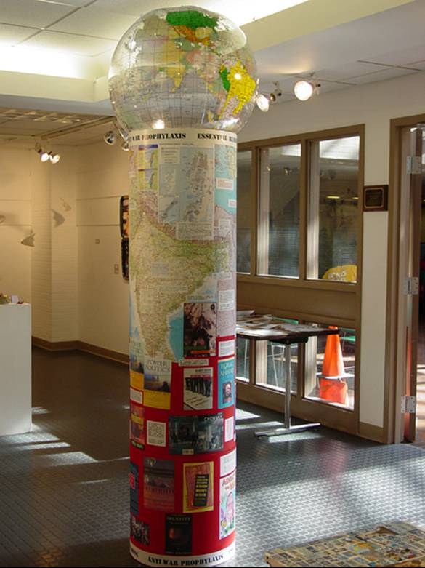

In the years since 9/11, artists’ resistance groups have sprung up all over the country, joining older resistance groups that date back to the Vietnam War. These groups include both trained academic artists choosing to make informed resistance art and grass roots spontaneous artists. In some cases they are interdisciplinary, in others artists focus on a particular medium, such as printmaking as is the case with the Beehive Collective. In Seattle, for example, The Global Art Coalition represents one example of this interface of grassroots and official gallery culture. An informal group of fiction and poetry writers, filmmakers, painters, sculptors, cartoonists, and musicians formed after 9/11, the Coalition met weekly to discuss what could be done by creative people to confront the crises of our times. We discussed the role and responsibility of the artist in the context of the newly polarized world, what was the purpose of art, what was the appropriate intersection of art and politics. How could we respond based on our own perspectives in a way that would have meaning for both ourselves and a larger audience? These are fundamental questions that were being asked by many artists all over the country. The Global Art Coalition culminated in “One Year Later,” an exhibition in a gallery at a community college in September 2002. Although grass roots in character, in that all the participants came together outside of an institutional affiliation, the ultimate result was a traditional gallery show. Yet, probably because of its subject, and the effective work included, as well as its location as at a community college gallery in an urban core, the exhibition drew almost 1000 people. It included some memorializing work, but it had an emphasis on global politics. The show took place after the Afghanistan war had begun and five months before the Iraq war commenced in March 2003. But, already in the fall of 2002, many questions about the WTC bombing as well as the government’s intentional lies to the American people about the reasons for a war on Iraq, were easily available.
The exhibition statement declared “The Global Art Coalition hopes to provide a forum for empowerment and dialog in a diverse community. As we recognize that the United States can no longer avoid the realities of the world, we wish to provide venues for exploration and education.” The educational component was central to the display. At the entrance to the show, a column with a map of the world immediately confronted viewers, covered with quotes from a wide range of authors on the subject of global imperialism. The quotes were placed over the part of the world that the writer was addressing. So over the appropriate part of Afghanistan, a quote by Arundhati Roy from Power Politics “For some years now an American oil giant called Unocal has been negotiating with the Taliban for permission to construct an oil pipeline through Afghanistan “ Over the map of Pakistan, quotes from the well known Pakistani writer Eqbal Ahmad’s book Terrorism, Their and Ours, laid out references to terrorism: “The official approach [avoids] causation. They don’t look at why people resort to terrorism. . . .The form that exacts the highest loss is state terrorism.” On the bottom of the column were the covers of the 2 dozen books from which the quotes were taken, and in a table in the exhibition were all the books available to read.
A large cartoon bar graphed the number of people dead from various cataclysmic events from wars to poison gas attacks. A sound piece “Interviews” broadcast excerpts from the 2002 State of the Union interlaced with comments by ordinary people on their feelings about the world. An interactive word game asked us to express our views on 9/11 and its aftermath. Various paintings represented domestic violence, homeland security, racism, oppression, and war as well as meditations for peace. At the opening there were healing dances, as well as a poetry reading by Native American poet, Gail Tremblay. Tremblay’s mixed media piece, Collateral Damage, scattered doll size women in abayas, with heads and arms missing, streaming with blood (indicated by narrow red ribbons) on a bare, brown ceramic field about two feet square and about two feet off the ground . Because of the scale we looked down on these figures, and knew that we were the imperialists who had killed them from the sky.
Accompanying the show, in a different venue was a film by Farah Nousheen, a young woman born in South Asia. Following the bombing of the Twin Towers she became concerned by the simplistic stereotypes of Islamic women that she was seeing in the media. She decided to organize a film festival and panel which she called “Nazrah, A Muslim Woman’s Perspective”. As she previewed the movies for the small festival (which took place in December 2001) she discovered that the voices of American Muslim women were missing. During the next year she filled that void by creating a movie of her own with the same name. Although she had never before made a movie, she was driven by her mission to explore diverse experiences and ideas about Muslim women’s lives and faith.

This collaboration between myself and my husband, Henry Matthews was called “Anti War Prohylactic” The quotes and their sources are an appendix on this chapter.
Twenty one artists were included in the exhibition.
Gail Tremblay’s unpublished poem.
Farah Nousheen has gone on to found Tasveer, a non profit which organizes annual festivals of independent film from South Asia. These festivals provide new perspectives on both Muslim women and South Asian life in general.

