PROFILE
Outside the Box: African American Writers Evade Stereotypes
©Susan Platt first published in Real Change October 30 – November 12, 2003

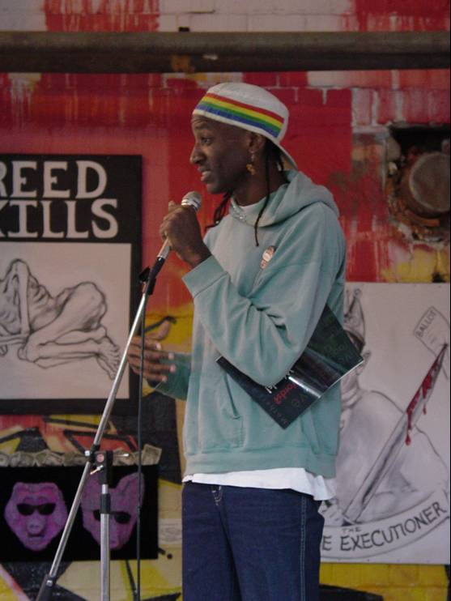

“I live with foolz that think they r better than those less 4 2 nate living on the street..”
Santiago Vega

“Too many people in Seattle think there is no racism like no place I have ever been.”
Georgia McDade.

Cultural apartheid is alive and well in Seattle. At the now virtually suburban Northwest Bookfest, I counted the people of color presenting on one hand . Although Sherman Alexie was the big draw,and he brilliantly tweeked his predominately white liberal audience, panel by panel, display after display (with the notable exception of Calyx Press, based in Oregon), there were only the slightest indications of the diversity of creative voices in the Northwest.
Last summer, I was disappointed, for a different reason, by the Pulitzer Prize winning play by Suzan-Lori Parks, Top Dog,Underdog at the Seattle Repertory Theater. Written by a smart, young, well-educated black woman, it presented the entire litany of negative clichés of black men in America. To be heard do black intellectuals have to play to racist stereotypes?
In the opinion of Georgia McDade, the articulate organizer of the African American Writers Alliance, a group of powerful poets, writers, and playwrights, “Top Dog” was written for white people. “African Americans juggle cultures all the time. The average white person doesn’t have to bother.” Blacks are completely aware of the differences of language, clothes, hair, etc that signify race and class. To be visible to whites requires fitting into a preconceived box of attitudes towards African-Americans. That’s why the African American Writers Alliance has invitations to speak mostly during Black History month. That’s why more people show up for their readings in response to a black artist than a white artist, although the human emotions of painting and poetry are universal.
Although racism has colored the life experiences of all of the writers in the African American alliance, each writer tells a different story in a different tone: hopeful, sad, spiritual, angry, nostalgic, humorous. Several are more engaged with spirituality than politics. I first encountered the African American Writers Alliance when they presented their work as a special program at the exhibition of the famed Seattle-based painter, Jacob Lawrence, last spring. I later spoke individually with a few members of the group in addition to Georgia: Olubayo Johnson, Frenchie La Motte, Kathya Alexander* and Santiago Vega. There are about a dozen active members and as many as two hundred writers have passed through the group since it started in 1991 by a California transplant, Randee Eddins, who couldn’t believe there was no writing group for African Americans in Seattle.
Practically all of the members moved to Seattle from elsewhere, cities like Cleveland, New York, and Little Rock, or towns like Monroe, Louisana. They range in age from twenties to seventies, and they write of the tragic, amusing, profound, mundane experiences of life. Some are spoken word performers, others write short stories, some rhyme their lines like hymns, others lay them singly down the page. Some speak of their own lives, others spin out fantasy. But all of them are obsessed with writing. They meet once a month to share their writing and talk about opportunities to present their work.
Olubayo Johnson, a member for seven years, and a transplant from New York City, describes how the group affected her “I always wrote, I never thought it was something. Finally I went. It was a non-threatening place, people were enjoying themselves. I began expanding. I write about places I lived, people I’ve known.” Olubayo has eight grandchildren and she has children in her house all the time; it is the honest words of children and their uninhibited freedom with their thoughts that inspires her writing. “They look with a fresh eye and see it for what it is.” “From My Chair” is about an eighty eight year old grandmother who sits on her front porch and experiences the world. “The Real Tragedy” about a thirteen year old girl who killed herself, probably because she was being abused by her stepfather.
Condé “Frenchy” La Motte grew up in New York City in a housing project near the Brooklyn Bridge. He got his nickname because he lived in France for three years as a military dependent. His father and uncle were right and left hand men to Malcolm X. Frenchy has been a musician since Junior High, but he dropped out of the School of Art and Design in New York, discouraged by the heroin culture that was killing so many of his friends. Then he got lucky He went back to school at a prep school in Newark, New Jersey supported by a scholarship and graduated valedictorian of his class. When his best friend, second in the class, died of a drug overdose, he was overcome with grief and gave up a college scholarship. He later got another scholarship to Whitworth College in Spokane and also played all over the Northwest with his road band “Fren-ship.”
Frenchy was inspired to write by a creative writing teacher named Daisy Aldan, a confidante of Anias Nin, at the School of Art and Design. He described the class as ranging from street blacks to flower eating hippies, but her persistent gentle love, discipline and steel, won them all over. Aldan also told him about black writers like Langston Hughes and Paul Lawrence Dunbar. In the 1970s La Motte was co-director and producer of the Black Experience Theater. Frenchy has been a single parent for eleven years and is still raising his five children who range in age from 31 to 14. He has worked as a doorman at the Sheraton for 21 years.
His brief poems are deceptively, simple chant-like statements full of metaphors: Broke Back Camel
The camel thought
“Damn what was that?”
As Hurricane Hate,
Rocked, rearranged and blew its mind.
Camel fell to calloused knees and groaned
Oooh by back.
Spine speared by hollow blond straw
Soul sucked by a death gray ghost
With a dollar sign Face.,
Wilderness weathered Camel
Could Stand no more.

As they performed their poetry inspired by the art of Jacob Lawrence at the Seattle Art Museum last spring, the members of the African American Writers Alliance wore all colors and styles, yellow pants, a bright blue dress, a flowing robe of brown Mali dirt cloth, a scarf of green patterns, and a shirt with as many colors as a stained glass window. They wrote poems inspired by the Lawrence series on historical figures like Harriet Tubman, who brought so many people to freedom on the underground railroad, whom one writer, Kathya Alexander, described as “my action hero.” For Angie La Baw, Tubman has another message “How much longer will it be before freedom comes to set us free?” Olubayo Johnson, sees in the “Migration Series” an example of love, faith and hope. Sonya Thompson in response to the “Builders” suggested that “we’ve built ourselves up out of the ruins of yesterday, demanding freedom at any cost.” For other poets, the color in the art works was as inspiring as the subjects: “my world is full of color and shape, I can make the world a better place bit by bit/ I can solve problems, heal wounds with one small stroke, the world on canvas, its all mine.” (Brenda Wright )

“Prejudice is alive. We do all sorts of things because of prejudice, sometimes good, sometimes bad.” Georgia McDade
In 1989, McDade was the first African American women to earn a PhD in English from the University of Washington, the result of years of perseverance. She did a masters thesis on Shakespeare. She was asked to write on an African American for her doctoral dissertation. Why, one wonders? Did the white faculty think they were shaping her career for her by directing her to an African American writer? Or did they doubt she could understand Shakespeare because he was white? For many years, McDade was the only black professor at Tacoma Community College and all the other “others” talked to her about their problems. “More blacks don’t succeed because of the burden or race.” Georgia spoke of how much energy it drained from her creative life to deal with racism all the time. “I could be using my hard drive for something else.”
McDade grew up in Monroe, Louisiana one of eight children. In spite of Brown vs the Board of Education that desegregated schools in 1954, the schools in Monroe were still segregated in 1963. McDade went to the all black Southern University in Baton Rouge and never saw a white teacher until her senior year.
McDade’s short stories combine her own family history with that of other people that she has met. Her stories reference events like the murder of her grandfather after a gambling game, her father’s early years as a sharecropper, or the life of her mother who was valedictorian of her class, and spent her life as a maid working for $3.50 a day. One theme of McDade’s short stories is dominating men and submissive women, but she also celebrates survival, her own and that of her family and friends. “The most amazing fact is that I am here considering where I started from.” It is her mission to help as many people to write as possible “Life could be so much simpler if they could write well” she comments.

“We all see the same thing. We all interpret it differently.” Santiago Vega
One of the younger members of the African American writer’s Alliance Santiago Vega is an outspoken performer. One of nine children (oldest son), he grew up in a black community near Cleveland, Ohio. He was diagnosed as “mentally challenged” in kindergarten and sent home, to the distress of his parents. He was also left-handed. His father insisted that he write a page every night with his right hand, and made him go to bed at 5:30. By first grade it was already clear that he was an exceptional rather than a deficient student, but his father never seemed to believe it.

Santiago read every night when he went to bed early and by the end of 5th grade he had read every book in the library in his school. Although he took part in gifted programs throughout his school years, and was a prize-winning long distance runner, his college guidance counselor told him he would make a “good auto mechanic”. In spite of all of these challenges at home and at school, Santiago went to college at Arizona State and chose to major in an accelerated Japanese program. He is currently teaching language at the Seattle Art Institute.
His poetry is outspoken and edgy. That edge comes out of his willingness to directly confront his long experience with racism, as well as to place it in a larger social context. These are not poems about his personal experiences, but about life in the United States.

“I live with foolz that think they r better than those less 4 2 nate living on the street
& like reggae $B!F (Bcauze it haz a cool beat
an x otic afro-carribbean sound
but when it comez 2 relatin 2 real African peoplez strugglez they r nowhere 2 b found
sure $B!D (B.they can quote statistics about Rodney or martin luther king
but when it comez 2 real actionz they wont do a thing
$B!F (Bcauze itz clear that they emulate
the very 4cez they claim 2 hate
so az they follow the empty guilded path uv the diamond bling-bling
they chooze 2 ignore what makez the caged bird sing”

The Central District in Seattle, historically a segregated black neighborhood, was the birthplace of Jimi Hendrix, Ray Charles, Ernestine Anderson and other extraordinary musicians, writers, artists and poets. Today it is gentrifying with sky high prices. But that does not mean that the city is now culturally integrated. The white cultural community is still mostly segregated from the many brilliant creative expressions by artists of color. Aside from the occasional event (“Day of the Dead” let’s find a Latino artist), these writers and artists are invisible. Thinking diversity for every event, because we are all humans with common concerns, is not even close to happening. If that sounds like an old problem, it is; unfortunately, it is still around.
We all lose as a result.

The African American Writers Alliance has published two anthologies of their works. They also perform as individuals. For more information or to schedule a reading
Contact Georgia S. McDade at 206 722 0964

