PROFILE
Art on a Mission: Farah Nousheen, Eddie Hill, Isangmahal
©Susan Platt first published in Northwest Colors, April 2003

Jacob Lawrence (currently on display at the Seattle Art Museum) dedicated his art to speaking for his community. His mission as an artist was to creatively celebrate the humanity of the African-American experience in America. The support that he received from the Harlem community in New York City in his early years led him to believe that he could dedicate his life to speaking for his community. Lawrence’s subjects range from the invocation of the historical African American migration to the North during World War I (organized poetically like a jazz composition) to the visceral experience of living in ghettoized communities. He paid homage to great acts of courage by both black and white leaders, the horrors of Hiroshima during World War II and finally to the crucial and ignored role of physical builders of our society both black and white.

But above all Lawrence’s art testifies to the capacity of human beings to survive amidst adversity through a sense of responsibility to community and to build a new hopeful world

A similar sense of mission based in community motivates the artists who are profiled in this article. Eddie Hill is an African American artist from Chicago who has a commitment to working with youth and to building connections between different ethnic and age groups. Farah Nousheen, a Muslim originally from Hyderabad, India wants to make the diversity of voices of Muslim-American women heard. Isangmahal collective, a Filipino-American spoken word group, composed of first and second generation artists primarily from Washington State, inspires members of their community to express themselves. They all share common goals of creating spaces for their community to speak. They are all working outside traditional academic approaches and they all expand our understanding of humanity, spirituality and creativity.

“My purpose wasn’t to ‘make a film’. I wanted to give voice to Muslim women. I chose film because that medium speaks to me the most.”
Farah Nousheen

Farah Nousheen describes herself as a post 9/11 activist. Following the bombing of the Twin Towers she became concerned by the simplistic stereotypes of Islamic women that she was seeing in the media. She decided to organize a film festival and panel which she called “Nazrah, A Muslim Woman’s Perspective”. As she previewed the movies for the festival (which took place in December 2000) she discovered that the voices of American Muslim women were missing.

During the last year she has filled that void by creating a movie of her own. Although she had never before made a movie, she was driven by a mission, to present many voices of Islamic women, to explore diverse experiences and ideas about their lives and their faith. Much like the stories that emerge from Jacob Lawrence paintings, Farah’s film is full of stories, here told by Muslim women. Their stories are also part of historical migrations and spiritual missions and they form a few pieces of the larger stories of Islamic women world-wide.

The movie Nazrah features twelve women, including Farah herself, as well as 7 young people who speak briefly. It is dedicated to her older sister Aapi. Most of the women in the film are from the Northwest and most of them didn’t know each other prior to the shooting of the film, but we see them in the movie creating a thrilling interaction and response to one another as they debate the questions of their faith and how it works in their lives. They come from many different countries of origin including Pakistan, India, Iran, Egypt and Canada, as well as the United States.

“If you are unwilling to undress
don't enter into the stream of Truth.
Stay where you are,
Don't come our way.”
-- Rumi
The film opens with this quote from Rumi. As Farah explains “The first poem is especially important because it sets the stage for the film. It is telling the audience to be ready to hear the truth. I am not saying that the film is speaking all of what TRUTH is. It's the truth of the women who are speaking. We are hearing “their” truths, so if you want to listen, stay. If you don't want to hear their truth, don't come this way. And you will have been willing to open (‘undress’).”Each segment of the film is introduced by a Sufi poem or other quote that provides a counterpoint to the women’s stories and a meditative perspective.

The film begins on a personal note as Farah presents photographs of herself at the age of 4 ½, a time when girls and boys in her Indian Muslim community are asked to recite the first verse of the Holy Koran, Surah Al-Fatiha, the first word of which is “Bismallah” which means “in the name of Allah” It is a festive event in the spiritual development of children within the Islamic faith in certain Muslim communities

Following Farah’s reference to her early experience, Mahnaz, whom Farah describes as a community activist, speaks with her daughter, Atefeh about how important it is for women to go back to the text in order to be educated and know their rights, particularly with regard to shared property. Each of the twelve women, who are law students, journalists, writers, teachers, and community activists, explore the meaning of their faith and its practice in daily life in different ways. They comment on many different aspects of spirituality and life, including travel, raising children, education, relationships with men, professional careers, teaching, and the many other challenges of a spiritual commitment.

Nazrah is not an abc of the Islamic faith; its purpose is to move beyond simplified essentialist ideas of Islam and to begin to educate its audience about the diversity of Muslim practices. Along the way, it uses some terminology that the mainstream press has distorted. We learn, for example, that the concept “jihad” means simply a challenging spiritual journey.

Farah visited two Islamic schools, one a bilingual full time elementary school, the other a Sunday school, and asked children various questions about Islam. The children all had different opinions and ideas about whether men and women should be separated in religious, social and educational settings. Sister Ifrah, the head of the Sunday School, commented that every child was from a different country creating a truly diverse learning environment. She also appeared at home, and spoke of the relationship of the Koran to raising children; at the end of the film, she articulately spoke on various aspects of the inner self in Islamic faith.

Farah describes herself as an “envoy” for these women. She felt empowered as she made the film. She was fortunate to have the assistance of Malik Isasis, a black underground filmmaker whom she just happened to meet as she was thinking about the film. He did most of the filming and provided the facilities for editing. Without his support, she never would have been able to realize her goal. Equipment was loaned by the University of Washington and Arab Film Distribution. 9-11 helped in providing space for screenings and other community groups also provided assistance.

The technique of the movie is unusual, the women often speak to each other, rather than to the camera, there is a sense of a bond emerging between them as they revel in the opportunity to share their different points of view, their different experiences. Farah adopted a format that let them speak about what was on their mind. On some occasions she asks a question, as in a discussion of the wearing of the hijab (head covering), in others the women speak directly to the camera or respond to each other. Having the filmmaker as part of the film is an unusual technique. The film’s format makes it a personal exploration by all of the women including Farah. (For more information on the women of the film see the website www. nazrah.org)

Farah has also co-founded Tasveer with Nazrah’s production manager Rita Meher, a filmmaker. Tasveer is a grass roots organization that holds screening of independent films by and about South Asia, as well as younger South Asian filmmakers in the United States. (tasveer.org)

Farah hopes to have the film included in the curriculum of college/university courses in humanities, the Middle East, gender, South Asian, theology, media & communication, and Islam. She is developing a study guide that will help with understanding the subtleties of the film. In fact, her hopes are already being realized. A college in Chicago has invited her to present the film in a few weeks.
(Note: Farah has continued her work up to the present with South Asian Independent Film Festivals, see http://www.tasveer.org/)

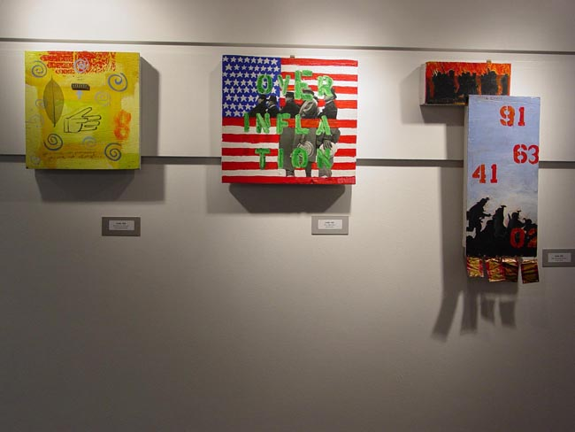Eddie Hill Installation in Global Art Coalition One Year After, Seattle Center Community College

As an African American artist creating links between traditional systems and those who are excluded from them, Eddie Hill has been directly inspired by the community based example of Jacob Lawrence’s early career: Lawrence was the first African American artist to be widely accepted in the white art community, but he never gave up his deep commitment to telling the story of African American life in America.

Hill calls himself a “border patrol agent” but he is an agent that facilitates crossings, rather than prevents them. He came into prominence two years ago when he and several other African Americans including Angelina McQuarter, Roger Mitchell. Harriet Walden and Michelle Blackmon began creating connections between the Seattle Arts Commission and the artists of color in Seattle. The resulting workshops “Unequal Access, Unaccessed Opportunity” provided a frank discussion of what artists and community advocates saw was causing these two communities to remain disconnected. The day long workshops led to real changes in perspectives on both sides. Michelle Blackmon is now a permanent liason at the Arts Commission, recently renamed the Office of Arts and Cultural Affairs. (Currently there is an exhibition of thirteen African American artists in a third floor space in Key tower. The exhibition remains up until May 9.)

Eddie grew up in a middle class family in the South Side of Chicago. Although both his parents are African American, he was harassed in school in the 1970s for not being black enough. (Now he knows that he is a mixture of Jewish, Irish, African, French, and Mississippi Choctaw). In 1980 his family moved him to San Diego, California where he experienced what he called a “different kind of racism.” He was placed in a predominately white community by his upwardly mobile parents, and found the experience from both sides of the line very oppressive. From San Diego, he then joined the U.S. Army and headed to Germany for three years, traveling throughout Europe until 1987. It was in Europe that he realized he could freely cross-racial borders, “people couldn’t determine my identity, and so I began to play a game with it. . . . I was experiencing a freedom I had never felt.”

But in spite of his peripatetic life, Eddie Hill’s model for art is based in the Chicago public art traditions, where workshops and studios, collaboration on public murals and revenue producing art by artists of color are all well established traditions.

His passion for border crossing led to the founding of Nu Tribes, a collaborative endeavor that filled a void in the Central District. In a multifunctional space (the former Welch’s Hardware at Jackson and 23rd ), Nu Tribes created a sense of community for what Eddie refers to as “artists of color and consciousness”. It was short-lived in its first location, but has recently been resurrected to organize an arts festival that will bring the predominately white Pratt Fine Arts in closer contact with its surrounding black community.

But Hill’s overriding interest is connecting with youth and emerging artists, encouraging them to express their feelings in art and murals; as an alternative to dead ends he wants to open up imaginations. He has worked at Meany Middle School and Gatzert Elementary. In this work he again walks in Jacob Lawrence’s footsteps, who also had a deep commitment to education and young people.

“There are no traps, only hesitations and self-placed obstacles,” he says. And indeed for Eddie, that’s true.

The isangmahal arts collective has similar community building goals for Filipino-Americans, as Farah Nousheen’s Nazrah for American Muslim women and Eddie Hill’s Nu Tribes for visual artists of “color and consciousness.” Their spoken word performances connect Filipino Americans, give them a voice, encourage self-education, and build community. At their recent sixth birthday celebration, the group exuded a powerful shared energy among its many young performers, some of them still in their teens.

Largely inspired by the lesson of the late Bob Marley, Jojo Gaon and James Ardena printed out simple flyers with the words “isangmahal: poetics & consciousness HELP WANTED.” Beginning with a make-shift open mic in a living room with candles and incense, 6 years later, isangmahal, the artist in residence group at the Northwest Asian American Theater fills the theater with its intoxicating presentations of poetry and consciousness shows. They still use their original format, featured artists and open mic. It is through the open mic that isangmahal offers opportunities for new talent to join them. Once part of the collective, the performers are part of a supportive community. The results are an extraordinary outpouring of strong ideas in a poetic format, with accomplished professional presentations.

Spoken word is the main form that their expression takes and music is often a part of the verbal traditions. Austin Veloria isangmahal house band leader juggles many instruments, saxophone, drums, guitar and bass, to make music with poetry, “often on the fly and always in the most organic process, . . . our poetry and music seem like they were meant for each other”, says architect/poet Maya Santos, one of the founding members. The music draws from jazz, funk, Filipino folk music, revolution songs, hip hop, soul, and reggae.

Currently, the collective includes about thirty Filipino-American artists, many of them first or second generation coming from a wide variety of different backgrounds ranging from high school students to graduate students, postal workers, non-profit workers, high school teachers and counselors. There are poets, visual artists, movement and dance artists, actors, djs, videographers, writers, analysts and activists.

George Quibuyen (Geologic) and Maya Santos, with whom I spoke, declared that isangmahal was not a political group in the sense of following a political party position. “isangmahal” means “one love” in the Filipino dialect Tagalog. While each performer has his or her story, the group philosophy is that “creating a loving space in which one can express their own perspective is a political act in and of itself . . . a form of liberation.” But that liberation often takes the form of outspoken statements about life in America or international politics presented in riveting poetic statements performed with great emotion.

Isangmahal art is based on hybridity: the voices of a marginalized point of view in the United States are inevitably coming from many different positions. George (Geologic) spoke of his own development, from writing poetry for himself, to getting on an open mic on August 99, to evolving from hip hop to a community based ethnic and class identity. Maya spoke, just as Farah did, of the goal of encouraging an art that provides a counter to essentialism and embraces many different reflections of identities.
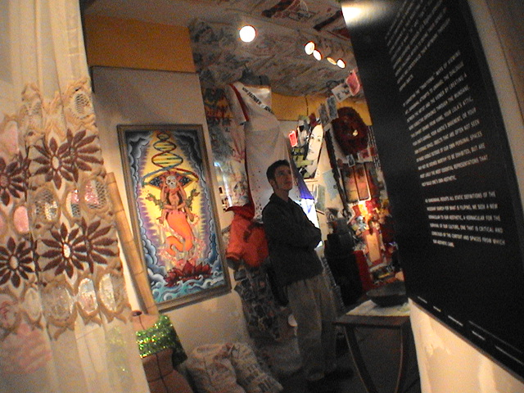
Installation “Assemblage Unraveling”

Last summer Maya joined Ethelyn Abellanosa , James Ardena and eleven other artists to create an installation at the Wing Luke Museum : “Assemblage Unraveling: Constructs of a Filipino American Aesthetic.” (June 6 – August 18.) It was an extraordinary mixed media display that burst from their personal lives and collective histories and celebrated the complexity of how they all came together as one beautiful collision. The collaborative process in which this exhibit came together was, in fact an “assemblage unraveling.” As the artists worked they asked question after question about who they were as Filipinos in America. The exhibit celebrated those complexities as well as a longing for who they once were before the colonizing began. Using memorabilia, videos, clothing, narratives, cultural artifacts, music, sounds and other media, the diverse stories begin to display a common aesthetic. This “vernacular culture of survival”, as they call it, comes from the stream of consciousness of isangmahal’s mottoes, “subvert cultural genocide” and “love your reflection.”

“Isangmahal” is above all a collaborating collective. Its draws its strength from its diversity and its shared commitment to a passionate creative expression. It is the synergy of the many artists involved that makes it effective, exciting, and path breaking. (Note: their current website is http://www.myspace.com/isangmahalseattle)

All three of these artists and their communities carry on the legacy of Jacob Lawrence’s mission to speak with the voices of those who are not heard, to connect people, and to inspire their audiences with new perspectives. The passion and spirituality of Farah Nousheen, the women of Nazrah, Eddie Hill and his collaborators in Nu Tribes and other endeavors, and isangmahal in its constantly expanding Filipino-American collective, all present the deep wells of creativity in our communities of color. They continue the tradition of telling that story first begun by Jacob Lawrence so many years ago.

Spoken Word by

Joe Lubong, 18 yrs old.
My yesteryears never had memories
in the memory and this is yesterday's letter to god
I used my mothers rosary to tie my shoes apart
I ran into problems dealing with being who I was
I am not half the person I used to want to be
the root of my family tree left my branches undone
my seasons are only winters
and my growth grows without the help of
swinging branches
they gathered us through

