COMMENTARY
Dance this Mess Around
©Susan Platt first published in Real Change, December 26, 2002 - January 8, 2003
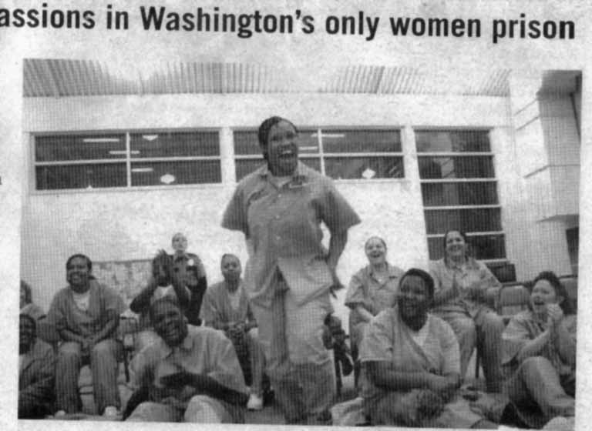
East coast hip hop company ignites the passions in Washington's only women prison

The whole roomful of 200 women stood up and cheered for Belinda Stewart, the Superintendent of the Washington Corrections Center for Women, when she began to introduce Rennie Harris and his fellow hip-hop dancers for a special performance at the prison. The women were honoring Stewart as well as welcoming the dancers. Superintendent Stewart took it all in stride, encouraging the women to “act like the ladies you are so you don’t give the staff heart failure.”
“Staff” is, of course, in the context of a prison, a euphemism for guards, but the atmosphere in the gymnasium where the special dance performance took place was definitely full of high spirits and mutual trust. Although the photographer and I passed through a heavy security check (we had to be pre-approved to even be admitted) and one locked gate after another, set in fences crowned with barbed wire, once we got to the gymnasium where the performance was to be held the atmosphere was more like a high school basketball game - with the same noise level - than a prison.

The Washington Corrections Center for Women is the only corrections facility for women in Washington State. It currently has a population of 900 women, whose crimes range from aggravated assault and murder to first-time violators for drug possession. Some of the women are in for life, others for only a year or two.

Christine Turull, the public information officer, told me that if a woman is pregnant when she comes to prison she can keep her baby with her for up to three years of age; currently there are twelve babies in the prison and the prison provides early childcare programs. Of course, practically all the women at the prison are mothers and the rest of them only rarely have the luxury of seeing their children, since most of them live far away, and frequently with foster families.

But this type of anguish was far from everyone’s minds as the women eagerly greeted Rennie Harris. His performance, “Legends of Hip Hop,” came to the prison through the initiative of Pat Graney and her “Keeping the Faith: The Prison Project.” Graney has been offering classes, workshops, lecture demonstrations, and performances for women at the Corrections Center for eight years. This year, she decided to have an inmate advisory panel that would suggest performers to bring into the prison. Rennie Harris is the fourth artist to come; others have been Amy Denio, a composer and vocalist, Gabriele Gutierrez, a poet and performance artist, and the poet Gail Tremblay. All the visiting performers also hold workshops with the prisoners.

Harris and his performers taught a master class in the afternoon, then performed twice in the evening (each time for about 200 women). The performance itself, “The Legends of Hip Hop,” included several different types of hip hop and dance. The point of the performance, as it is being performed in art and theater venues all over America, is to demonstrate that hip hop has roots in African tradition and culture of the Diaspora (African American, Afro Brazilian, Afro Cuban, Puerto Rican), and that this vernacular street dancing, with its popular roots, can also create riveting dance theater. Harris has pioneered the transition of hip hop from the street to the stage.

Hip hop emerged as part of a street culture of rap music, break dancing, and street graffiti in the 1980s. Originally it developed as an alternative to gang warfare, as a way of “fighting without fighting.” A hip-hop artist only needed a piece of cardboard and a boom box to go off to a street corner and perform.

“Legends of Hip Hop” is a more consciously orchestrated presentation than its casual street-based roots. It began with moves like “popping,” demonstrated by Harris, then featured one of the living legends of hip hop, Don Campbell, in his “lockin’” technique. Campbell - in red and white striped stockings, a black and white striped shirt, bowler hat, red jacket, and red pants - cut a striking figure as he danced with the flexibility and energy of a 20 year old.

Next up were the “Untouchables,” three young men who performed a choreographed piece with rapid changes of pace from fast to slow. Last was a group of three dancers who performed individually. Richie Soto, Flipz, and Forrest Webb each had his own style, lifting, diving, and spinning on heads, hands, or legs.

Although he invites various other groups to perform with him, Harris has his own “Puremovement” company that he started in 1992 as a hip hop dance company. One of his early pieces, “P-Funk,” is dedicated to dancers “who have lost their way or have been slain in the streets.” “Facing MeKKa,” his current work, consciously draws attention away from hip hop as spectacle to hip hop as a dance performance that has the same universal appeal as any other art form. (See his website puremovement.net for more information). He sees movement as a means of creating community.

That is certainly what happened at the Washington Corrections Center for Women. By the end of the high energy performance, we were all equally dazzled by the creativity and talent of the dancers. These young men were all as powerful and formidable as dancers in elite ballets or modern dance performances. One reviewer has compared the head spins to an upside down version of a tour de force classical ballet move.

Harris followed the performances with a question/answer period. He emphasized that he and his performers succeeded through hard work to make a living, but that little separated them from the women in the audience. “We all came from the streets, from the projects,” he declared, as the women cheered. “These dancers went ahead and committed to performing once they realized they could make a living.”

Harris himself works on the principle that “every individual is a creative reservoir waiting to be tapped.” He believes in the power of art to transform people’s lives as a creative and spiritual force, and he uses his performances to emphasize the common ground among people of different cultures.

At the end of the performance I attended, one of the women stood up and asked, to wild cheers and laughter, “Will you be my Daddy?” It was a poignant moment.

--------------------------------------------------------------------------------
Julian Matthew provided background information on hip hop. Susan Platt is the author of Art and Politics in the 1930s (Midmarch Press 1999) available at Elliot Bay Books and the Seattle Art Museum.

