EXHIBITION REVIEW
“Lubbock: Designed Obsolescence/Third Floor”
©Susan Platt First published in Art Lies Issue 46, Spring 2005

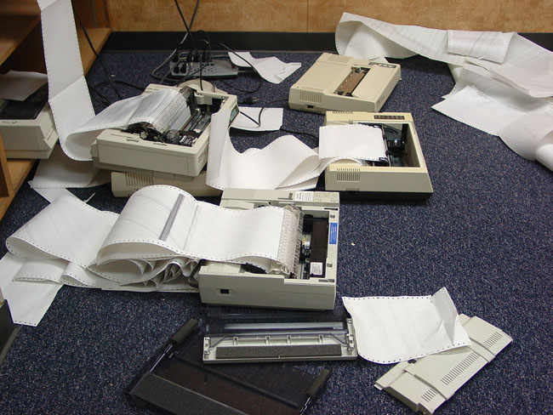

Installation view

In December 2004, an architect (Szu-han Ho), a musician (Zachary Watkins), a photographer (Robert Meers) and a painter (Chad Dawkins) got together in a nondescript building in downtown Lubbock to think about staging an art show. On the third floor of the seven-story building, they found a room overflowing with obsolete office equipment, some of it dating back decades. It was like a time capsule—1983 Apple computers, Portafaxes, Scantron machines, Krown phones, modems and printers, reel-to-reel projectors, microfiche readers, Polaroid ID equipment, dot-matrix printers, perforated paper and so on. Built in the 1920s, the building served as the West Texas Hospital until 1974. Sometime in the late 1970s, South Plains Community College remodeled the interior. Accordingly, the group also found medical and educational detritus—motivational posters, tapes, medical illustrations, cooking show videos, training manuals for remedial skills—that referenced the space’s varied history. It was a view into out-of-date concepts, as well as out-of-date technology.

This found mix of obsolescence led to a couple of months of brainstorming sessions. Somewhere along the line, two more artists joined the group: Shreepad Joglekar—a photographer from Mumbai currently in the process of shifting from commercial to fine art—and Piotr Chizinski, a business sector dropout who loves regurgitated machinery. The result was an installation that took up fifteen rooms. Even in its excess, there was a prevailing wit and unity to the show—an understated absurdity based on the conjunction of machines, light, sound and visuals. Although some of the pieces could be attributed to individuals, the installation was really the result of a creative partnership between the machines and learning props, the artists and the space itself.

In the elevator, a trio played serious classical music, setting up a witty tone and aesthetic that ran throughout the exhibit. As soon as the elevator doors opened, the sound of multiple machines amplified by contact microphones displaced their music, creating an accidental symphony. Humming, screeching, clicking, whirring, whining, vibrating and chugging, these noises also merged with voices coming from instructional videos and audiotapes. In the stairwell, a sound piece by Watkins also scrambled the sounds of rainstorms and people walking through the space.

The first room held one of several collaborations by Chizinski and Dawkins. The pair set up five old monitors, offering interactive programs obviously intended as remedial aids. The room was dark; the monitors glowed with green letters and everyone over twenty felt a flash of nostalgia. The machines seemed animate—benevolent old friends that spoke to us when we touched their keyboards.

In the next two rooms, the pair piled a half-dozen dot-matrix printers on shelves with paper churning back and forth in an endless loop, followed by a bone yard of broken monitors and keyboards, as well as printers issuing high-pitched whirring noises and low-pitched clacking sounds. Ho’s row of glowing trash cans led down a hall to another room with a sound and light collaboration with Watkins, in which an oscillator circuit board responded to fluorescent light. As bulbs flickered on and off, their amplified sound shifted from a high-pitched whine to a low-frequency vibration.

Joglekar printed texts from Kafka’s Metamorphosis and Marguerite Duras’ The Malady of Death on an antique modem. Fifteen feet of paper trailed out of the room and into a microfiche reader, where fragments popped up in huge letters. Words jumped off the screen, forming random and incomprehensible messages. Computer paper under foot turned into medical illustrations in Meers’ installation. Meers covered the entire floor in one area, creating the opportunity to work out any hostilities one might harbor toward Western medicine right there on the spot. His main contribution, though, was a lens from a slide projector placed in a dark room to create a sort of camera obscura. It projected images from outside the room, creating a shadowy performance out of the movements of anyone who happened to pass by.

In the largest room, Ho and Watkins staged an improvised concert with Ho on violin and Watkins on an assembly of electronic toys—a kid’s keyboard, a Simon Says game, an ET walkie-talkie set—as well as AM radios and contact microphones.

Designed Obsolescence spoke as a metaphor for the breakdown of the dream of technology and the myth of our society’s permanence. Everything will end up like the equipment found in this building—a heap of unusable, out-of-date ideas as toxic as the mercury in old computers. Yet the show also spoke of the crucial necessity for play, creativity, absurdity and incongruity in the face of inevitable disintegration.

Collaboration and its potential creative freefall are often neglected in the uptight, self-conscious art world. Perhaps this type of risk-taking synergy can only happen in a place like Lubbock, where no one has anything to lose. Ho, whose family foundation bought the building with the hope of jumpstarting revitalization in downtown Lubbock, succeeded in bringing renewed energy to a desolate corner. This may just be the start of an avant-garde community on the High Plains.

