EXHIBITION REVIEW
“Portland: The Clement Greenberg Collection and Voices of Water”
©Susan Platt first published in Art Papers Magazine, November 2001
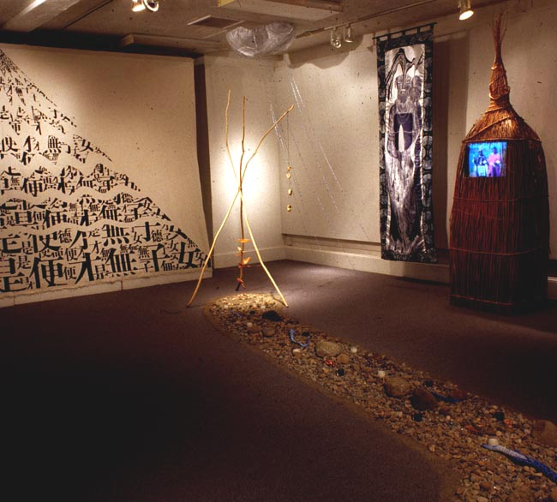

How much the world has changed in the last 30 years and how much the mainstream art world really wishes it would all stay the same: Two exhibitions in Portland document that contradiction. Color field paintings like those in THE CLEMENT GREENBERG COLLECTION (Portland Art Museum July 14 – September 1,) hold up well as a demonstration of confidence in the power of color to hold a canvas as well as the power of a critic to determine success. “The Greenberg Collection “is based on gifts to the critic from his grateful artists, among them Jules Olitski, Kenneth Noland, and Anthony Caro. The collection demonstrates just how single-minded these artists could be with the confidence based on Greenberg’s emphatic statements on the importance of visuality and flat painting. The Portland Art Museum purchased the entire collection from the artist’s widow, Janice van Horned, giving Portland an indisputably important chunk of modernist history.
But even as these works were painted, primarily in the late 1960s and 1970s, their underpinnings were already wearing thin. Today there are new perspectives and new histories, and sometimes those new histories are simply a return to very old histories, and an acknowledgement of our fragile relationship to the planet. Water is the most fundamental aspect of that fragile relationship as well as the theme of VOICES OF WATER (Interstate Firehouse Cultural Center July 2 – August 26), a collaborative installation curated by the well known native American poet and critic, Gail Tremblay, that includes seven artists from two continents. The exhibition is bracketed by photographs and drawings that document Betsy Damon’s Living Water Garden completed in Chengdu, Sichuan province, China in 1998. Damon worked with local experts to design a six- acre water quality environmental education park that demonstrates a seven stage water purification procedure. The physical directness of this piece connects it to late modernist earthworks, that aim to be healing rather than destructive, and creates a prelude and postlude to the rest of the exhibition.
At the center of the first gallery water drips on a rock as it falls from a series of split bamboo channels suspended from the ceiling. As the sculptor, Li Xiuqin, explained, in China it is believed that water coming from bamboo is pure and that while the water is soft it can open the earth, make a river, or cut stone. Along two facing walls is a dried stream bed of pebbles with brightly painted snakes whittled from scraps of wood by Imna Arroyo, an artist originally from Puerto Rico, and, above it, an empty fish trap woven with sweet grass by Gail Tremblay in a traditional Native American technique.
Inside another, oversized fish trap container made by Tremblay, Imna Arroyo’s video The Many Faces of Yemaya is the partner to her eight foot high expressionist woodcuts of the water Goddess printed on satin. The video and the woodcuts invoke the seven forms of this syncretic Goddess in Santeria and Voodoo who inhabits all types of water, the sea, the forest, the rivers, the foam, the depths, and even the polluted waters.
As the sounds of water played on the video, there were simultaneous sounds of moving water within the glowing hollow rocks by Shi Hui, who applied a pulp made from discarded Chinese rice paper to a wire mesh shaped over an actual rock. In traditional Chinese painting, she explained, mountain, stone, and water are the center of all things. Water marks stone and defines rocks. In “Voices of Water” Hui’s rocks actually speak, not only with the sound of water, but also with the word “water” spoken in fourteen languages (recorded last summer in the Czech Republic) and commentaries by herself and Li Xiuqin in Chinese on their perspectives on water. Other voices included native America leaders on the importance of water for their culture in both the past and the present, a narrative about traditional canoeing, and a prayer of dedication for the “Celilo in lieu fishing site,” a fish platform above the Dalles, Oregon, built after traditional fishing sites were blocked by a dam. There are a total of four audio tracks.
Another dry pebble streambed by Imna Arroyo flows from a tripod sculpture by the Native American artist Lillian Pitt. Under the tripod, a spiral of two inch ceramic represents a Native American elder figure known as Tsagaglal (“She Who Watches”). Tsagaglal is both the subject of a legend of a female chief of the Columbia River Basin and the image on a 7000 year old petroglyph that overlooks the village of Pitt’s great-grandmother. These masks appeared in several places throughout the “Voices of Water” in different sizes. The legend was, according to Pitt, that Tsagaglal was the wise woman of a non-hierarchical society. Coyote told her that people were coming of different colors, but she didn’t believe him, so she was turned into a rock.
Above the river bed with its protective tripod was a rain cloud made with a piece of fabric brought from China by Shi Hui. Rain made from long strings of tiny beads by Tremblay fell down from it. On another wall was Water Cleans the Mountain by Li Xiuqin. The artist wrote the Chinese characters for the Confucian saying “The virtuous woman is without knowledge” across a white cloth shaped like a mountain. She then washed the calligraphy away in waves that increase in size until the writing is illegible at the top, thus, as she put it, “making new life possible.”
Arroyo’s film is only six and half minutes long. Most of the time, the video monitor is playing Laurie Meeker’s film “The River People” (1 1/2 hours, ten years of work and still in progress). It is collaboration with Meeker and Lavina Washines, a member of the Kahmiltpah band of Columbia River Indians who provided the conceptual framework for the film. The oral history narrated in part by native elder Louise Billy and translated by her daughter Ella James speaks of contemporary practices as well as the historical removal of many of their ancestors along the Columbia River The movie shows contemporary fishing and gathering of native foods, as well as the ongoing disruption by dams and other environmental practices that mean that “this way of life has been almost wiped out,” as Louise Billy puts it.

By approaching the subject of water from many different cultures, while at the same time presenting artists who are completely contemporary, Tremblay challenges conventions on many levels. The urgency of its message about water on the planet historically, mythically, and in the present, revealed itself only gradually. The artists work simultaneously with still living traditions and postmodern media and concepts. In addition, they collaborated on the installations, combining their ideas in a synergy that is rarely seen in contemporary art, challenging us Western, driven, linear types (raised on Clement Greenberg’s confident assertions) and inviting us to allow the multi-layered indirection of the exhibition to seep into our consciousness in order to take action against the continuing destruction of the planet.

