COMMENTARY
“Changing Scales: Gail Tremblay: Twenty Years of Making”
Sacred Circle Gallery of American Indian Art May 31 – July 28, 2002
©Susan Platt first published in Raven Chronicles vol 10, no 3. 2003

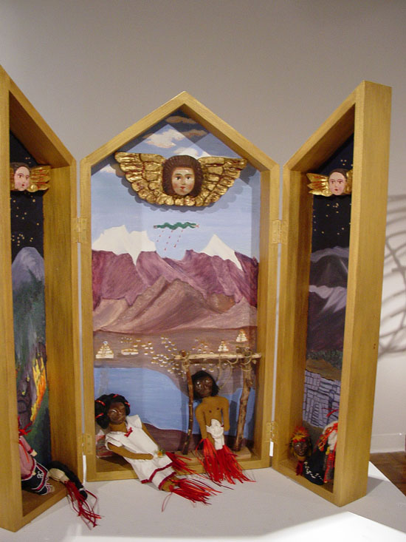
PART I DEATH
The Things Colonial Angels Witness: a tableau triptych (1992). Wood, paint, cornhusk, leather, clay, feathers, beads, ribbons, jute rope. Small gold winged angels in the “colonial baroque” style hang in the sky above three landscape scenes before which lie dismembered Indians, with blood streaming from their limbs.
Gail Tremblay uses dolls to help us to understand the violence of massacres. Dolls. Dolls have been colonized in American culture; they have been reduced to absurd commodity stereotypes, perhaps because they still have so much power to contain our fantasies, our feelings, our hatreds, our hopes. I remember as a child my deep attachment to my worn out mismatched collection of dolls. They were my only friends. They were the ones who knew all; they were the ones who told nothing. Gail Tremblay’s dolls are likewise our friends, they do not speak, but they show us their violently dismembered bodies, streaming with blood (streams of red ribbon), they tell us of their violent ends in their own language, the language of the body. Because they are small, we feel our power over them, our power to ignore them, to toss them aside, or to fully feel their mute suffering and tragedies.

Memorial to Indians Massacred and Disappeared, (1992) wood, paint, lava rocks, beads, white stones, clay, leather, linen yarn, cloth and ribbon These dolls are distributed in a box of lava rocks; they are also dismembered and bleeding. On the sides of the box are short phrases like “People without Reason Work to Obliterate Indigenous Wisdom.” “Pinochet has a Columbus Complex” We tower over the box, we see the dolls, the dolls are helpless, their souls have left them. They have been killed.

Iókste Akwerià:ne: It is Heavy on My Heart (2002) A room sized installation with large felt sculptures or organs with cancerous tumors, DVD, audio tape of native songs, color copies of cancerous organs and cells, small felt sculptures of spiderwort, normal and irradiated
The installation takes us over, rather than the other way around. It has a larger than life scale. Built out of felt, huge tumors grow on lungs and diaphragm and the thyroid gland. The cancerous tumors inhabit the room on the scale of human bodies, they invade our spirits, they invade our feelings. The felt surfaces seduce us with their beauty, but at the same time, the organs speak to us. Unlike the mute dolls, these organs speak; tell us their story, they testify, through the voices of many different Indians and many tribes, through images of cancer infected fish and polluted landscapes. They weave a tale of betrayal, the old tale and the new tale. The tale of the nuclear industry, its assault on traditional native lands, its campaign to deposit its waste on Indian lands, its careless removal of Indians or cajoling of Indians with money. The elders speak of the illness that the nuclear industry and its invisible radioactivity causes in their tribes, birth defects, growth delays, leukemia, skin diseases, asthma, heart disease, cancer, breast, lung, colon, prostate. They reply with legends, with poetry, with a clear alternative to the stealing of the insides of the earth, they speak of their way of life, their principles of living in the land, but not gaining from it. Grand Canyon, Navaho, Hvasupai, Laguna, Acoma, Shoshone, Peyote Yakima Colville, Wishwram, Prairie Island, Apache Choctaw. Sioux. These are the tribes of the tellers of the tale The poet Arthur Tullee wearing a bright red shirt recites his exquisite poems of legends of death, sickness, and healing.

PART II LIFE
Beside these scenes of devastation are the counter energies of life. Shooting Star (1990) cotton quilt with leather, porcupine quills and beads. In the Beginning, (1990) cotton quilt with leather, porcupine quills, beads, and moose hair. Shooting Star is subdued grays, blacks and white, a star bursting from the edges of the universe. In the Beginning comes from the center with pinks, purples and blues multiplying. Long before there was abstract painting in America, there were abstract patterns that represented the order of the universe on ceramics, quilts, pots and sand paintings. These stars refer to creation stories of tribes such as the Iroquois and Onondaga, they are in some cases, lost stories, stories that could not be passed on because of the spread of sudden death with the arrival of the plagues of smallpox. So these quilts present us with the image, and suggest their long history, without telling a story. They are meditative. The stars have no scale, large or small, for what scale is a star? How do you measure it?

Exploding Star(1991) aluminum sheet, brass wire, brass sheet, brass tacks, metallic braids, paint and wood. This is a more violent image, a dangerous variation, jagged cut from aluminum and painfully woven together with brass wire The exploding star is once again the invasive culture of consumption, using the materials from deep inside the earth, a process that is driven by a desire for power. This whirling jagged form is no longer the peaceful historical legend of creation. It is the story of the energy that can drive all others away.

Incandescent Cloud Brings Gifts of Rain (1990), wool, maribou feathers, metallic yarn, glass and metal beads, parrot feathers, anodized wire, padouk wood. The four harness waffle weaving in wool glows with pinks, oranges, yellows. It seems to dissolve into light, sun, and joy. It is so beautiful, that it resurrects our faith in the world. And besides the weaving is the Medicine Bearer, (1981) a mask of a healer, woven from linen yarn, metallic yarn, feathers, ribbon, beads, nickel silver. It is accompanied by a poem of the same title. The mask is the only life size form in the exhibition and watches over us protectively at the juncture between the historic myths of creation, the historic death of tribal peoples, and the contemporary world of disease and healing.

Sky Woman Falls to Earth making my Ancestors Possible. (1989), cloth, leather, beads, ribbon, sliver, brass, pictures of the artists grandparents and great-grandfather. This triptych is a frame for a single doll size figure dressed in white and riding a swan. She is the legendary mother of creation who was impregnated by a star on her way to earth. Her first daughter had twins, the second twin ripped her apart. When she was buried, sister’s corn squash and beans were born. This creation legend is brought into measured history on the back with photographs of the artist’s own grandparents and great grandfather. Timeless legend is part of our world.

The Film Baskets
My Most Wanted is the Red Leader (2001)

Among Stars of the Silver Screen, Nobody Tops the Red Leader(2001)
Sing a Birdsong for the Earth: Bird in a Blue Dress(2002)
Not a Coppertone Tan (2002)

And Then There’s the Hollywood Indian Princess(2002)
These are the names of the film baskets. The artist weaves these baskets in traditional stitches with 16 mm film, leaders and trailers. Some of the stitches are bird mouth stitch, porcupine stitch and strawberry stitch. They are a witty counter discourse to the Western cowboy and Indian movies in both their titles and their form. If you go to the Portland Art Museum, displayed along with more traditional sweet grass basketry is one of Gail Tremblay’s film baskets. She transforms tradition with these baskets, as well as putting Hollywood in its place. The baskets control the cowboys in a weave from which there is no escape. All that is left is a small transparency. The larger than life- size screen heroes of the movie theater have been reduced to tiny bits of color on plastic.

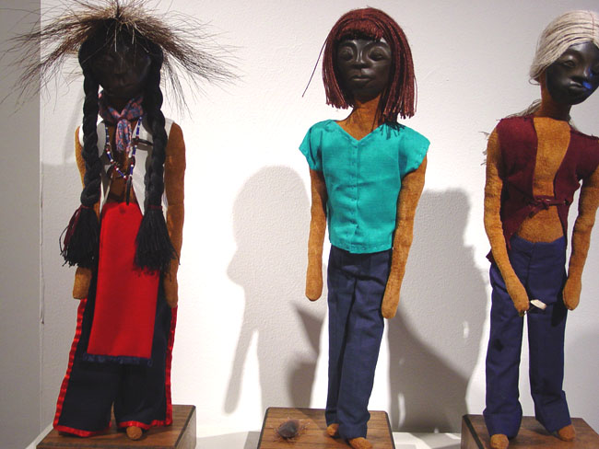
And the witty entrapment of the film baskets leads us back to more dolls, the three characters who are In Search of the Ultimate Roach Joke: (1994). They are made of leather, clay, cloth, ribbons, beads, porcupine claws, metal, a feather, porcupine hair, linenyarn, wood, a plastic cockroach, a safety pin and an oregano roach:

“I went to the powwow, took out my suitcase, put on my outfit and my roach.
A Roach !!!!
Hey man did you say you found a roach ?”

Gail Tremblay also weaves our spirits into these artworks and takes us on a journey with her extraordinary technical ability, her words, her deep caring for the earth, and her sense of humor. On the journey we enter small worlds and large worlds, the outer universe and the inner universe. She hopes that we end up caring about all of it as much as she does.

