EXHIBITION REVIEW
“Seattle: Gail Tremblay: Twenty Years of Making”
Sacred Circle Gallery of American Indian Art
May 31 – July 28, 2002
@Susan Platt first published in Art Papers November 2002

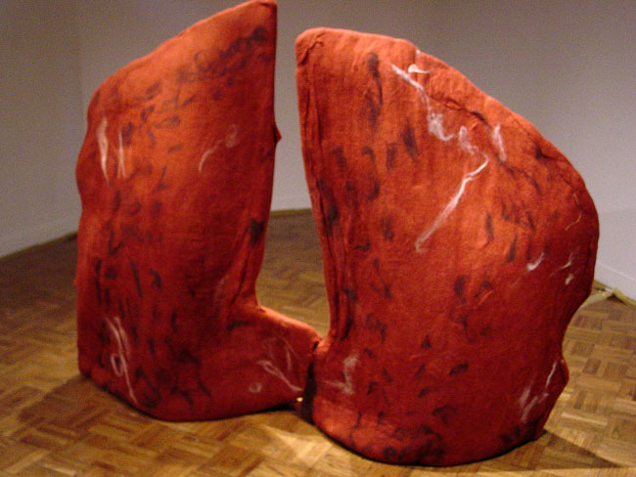

Gail Tremblay, Lung and Diaphragm Tumors, 2002, felt

Gail Tremblay’s recent retrospective exhibition at Sacred Circle Gallery of American Indian Art included work from various decades in her multifaceted career. At first glance, she presents a few elegant late minimalist sculptures in her newest installation, Iókste: Akwerià:ne/ It is Heavy on My Heart 2002) –a larger–than-life size felt form has the presence of a tribal elder or returning life spirit, who stands with dignity in the gallery. To one side a rounded felt form lies almost flat, to the other two crescent shapes stand upright. The earth toned or reddish felt with flecks of white is seductively attractive.

But the shapes are chanting. Then gradually drowning out the chant is the steady tones of a multi-voiced narrative of a documentary running in a DVD embedded in the standing “figure”.

Native Americans are telling a story, but this is not an ancient story from centuries ago, but a story that begins in 1942. It tells of the displacement of the Yakima Tribes of Washington State from their ancestral hunting ground when the Hanford Nuclear Reservation was created during World War II. It tells of the tumors and cancerous sores found on the fish taken from the Columbia River today, as a result of the contaminated overflow drain into the river, and of the illnesses developed by members of the tribes along the river, birth defects, many forms of cancer, growth delays, skin diseases, asthma, heart disease. It tells also of the tribe that lives at the bottom of the Grand Canyon with no cars and no stores, who gather off the land without any gain, but who resist 90,000 uranium mining claims. It tells of other tribes and other struggles against the dumping of nuclear waste in Indian reservations. As the narrative unfolds, over the course of an hour (it takes patience to enter Native American time) the felt forms emerge as something quite different from elegant shapes: they are cancer infected organs.

The standing elder spirit is Lung and Diaphragm Tumors in a case of Epithelial Mesithelioma, the round shape is Sclerosing Heptocellular Carcinoma and the paired crescents are Papillary Carcinoma in both Lobes of a Thryoid Gland.

Tremblay like coyote, tricks us into seeing the beautiful paired with the evil, the nightmare partnered to the poetic.

All of the works in this twenty year retrospective have layers of meanings and complex stories built into their seductive use of materials. A casual visitor will see stunningly beautiful weavings, masks, baskets, dolls, and paper abstractions, made in sweet grass, linen, rope, metallic yarn, beads, wood, cedar bark paper, porcupine quills, leather, maribou feathers, wool, wire, wood, felt, husks, splints, film, photography, video, sound, and poetry.

But Tremblay combines a profound knowledge of native materials and techniques and stories with biting commentary.

She wove metallic yarns through metal on a brass wire warp in Exploding Star, 1991. The physically painful and time consuming process was a meditation on native stories of birth and death as well as on the false glitter and environmental degradation that comes from our greed-based decisions to remove substances from the core of the earth.

Baskets made of 33mm film are, like the elegant felt sculptures, more than what they seem to be. In My Most Wanted is the Red Leader 2001 or And Then There’s the Hollywood Indian Princess 2002, made of red and yellow film leaders woven in traditional fancy stitch patterns, the material used to produce Indian stereotypes is reabsorbed into native weaving traditions and illegible transparencies.

These multiple transformations, aesthetic, technical, narrative, social, are at the heart of Tremblay’s amazing work. Tremblay is, above all, a poet who uses abstract forms to suggest powerful ideas. Native American cultures have used abstraction as symbols of abstract ideas for centuries. That is Tremblay so cleverly trumps white culture with her subversive technical and cultural games. But in spite of its seductive use of humor in works like Real Indian Medicine (1993) and In Search of the Ultimate Roach Joke ( 1994), the real theme of the exhibition is the hope that we can still correct the spiritual imbalances that currently disrupt the balance of life.

