COMMENTARY
“Changing Models for Public Art: Seattle’s Salmon in the City”
©©Susan Platt first published in Sculpture Magazine June 2002
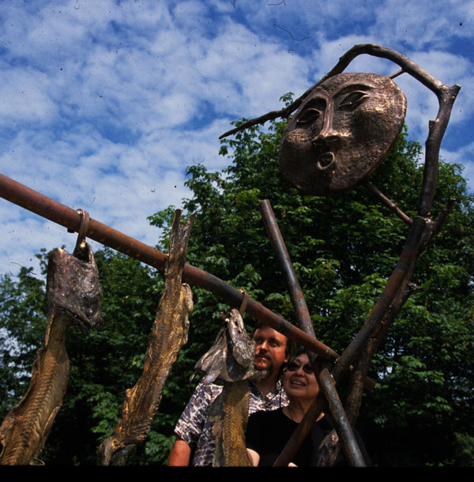
Lillian Pitt and Kenneth Mack Salmon Drying Rack 2002 dedication summer 2002
This sculpture was donated to the city of Seattle by the artist, in memory of Bernie Whitebear, but it has not yet been installed for lack of funding

On March 24, 1999 Seattle received the shocking news that the Chinook salmon was officially listed as an endangered species. Two years later, Seattle received more bad news: drought and power crises further threatened salmon habitat. Chinook salmon, the largest of all salmon, live in the ocean for five to seven years before returning to spawn upstream. They require a carefully protected freshwater environment for spawning and an easy passage back to the sea. For centuries salmon have been the lifeblood of Puget Sound peoples, serving not just as food, but also as a spiritual source for the community.

Seattle is the only major metropolitan area in the U.S. that includes a prime habitat for a federally protected species. City agencies work constantly to sustain and protect the interlocking relationships of water, power, and fish habitats. Water levels are monitored, streets rebuilt with new drainage systems, woody creek habitats restored, culverts and other blocks to spawning removed or redesigned. But only three Chinook adults spawned in 2000. More than 40 salmon populations are already extinct in Washington State.

The Seattle Arts Commission responded to new concerns about salmon habitat restoration with “Salmon in the City.” The multi-media project demonstrated the ways in which the Seattle Arts Commission’s Public Art Program, led by the intrepid and imaginative Barbara Goldstein, continues to reinvent itself and the city of Seattle. Fifteen temporary public artworks appeared all over Seattle in the spring and summer of 2001, with funds from Seattle City Light and Seattle Public Utilities Percent for Art Program and support from City Salmon Team and Seattle Parks and Recreation. The artworks included poetry, photographs, performances, banners, boats, barbecues, animation, installations, and sculpture. Work appeared at shopping malls, parks, and schools.

Two of the artists, Peter De Lory and Dan Corson, were part of the ongoing “artist-in-residence” program. An artist-in-residence actually works at a city agency, learns about it, and produces art that forms links between the agency and the populace. At Seattle Public Utility (water supply, sewer, drainage, solid waste, and engineering services), De Lory made black and white photographs of the employees at work, extraordinary structures (such as huge pipelines running through watershed forests), vehicles, and facilities. Although his work concentrated on how the utility operates, the process of supplying water to Seattle is integrally connected to the problems of protecting fresh water habitats for spawning salmon.

Sculptor Dan Corson works with structures and systems rather than objects. At Seattle City Light he observed that dam operators watched twigs bobbing in the stream through a remote video as a means of monitoring water levels and developed a more environmental approach. Through a live feed on the city’s optic link, Corson’s Skagit Streaming uses three cameras—underwater (fishcam), on the shore of the river (bearcam), and microscopic (bugcam)—to project real time information about the river. It is projected on the Web at www.cityofseattle.net/skagitstreaming, on monitors in City Hall, as well as on a 28-by-40-foot screen on the wall of a center-city parking garage. Standing in the middle of Seattle, you can view spawning salmon, insects, animals, vegetation, and micro-organisms.

Shaping cyberspace as an alternative type of sculpture is an increasingly prominent aspect of public art programs. Kim Stringfellow’s interactive Web site: www.salmoncity.net, specifically created for “Salmon in the City,” targets the urban viewer and water consumer with its slick color scheme on a black ground, but it also contains a technically and intellectually sophisticated tour of basic facts about salmon. It is still accessible long after the other temporary projects have vanished.

Brad Miller’s 30,000 Vanishing Species is, in contrast, as ephemeral as the public wants to make it. At various community events, Miller gave out a salmon print on undeveloped blueprint paper in light-blocking envelopes. As a metaphor of our stewardship of the environment, the print disappears when exposed to light; if it is treated with the proper chemicals, it will turn blue and be a permanent artwork.

Circulus, a multi-media installation by Kevin Johnson, Christine Bauemler, and Kelty McKinnon at Rainier Beach High School, was inspired by the restoration of salmon habitat in the Duwamish watershed, a heavily industrialized canal south of Seattle. It included historical maps of the river before it was straightened, texts about the river, test tubes of water, light boxes with images of human and salmon circulatory systems, and other components. The artists worked with art and science students at Rainier Beach High School in South Seattle, one of the most ethnically diverse parts of the city, as well as other groups from near the Duwamish.

Brad McCombs placed Hydrological Legends at the Hiram M. Chittendon Locks. The Locks, which divide the salt water Puget Sound and freshwater lakes in Seattle, are a popular recreational destination, but also a major block to spawning salmon. McCombs created two maps on the ground near the visitor center, one depicting the watershed 150 years ago and the other showing the altered migration patterns after the introduction of dams and locks. On one day in May, McCombs also introduced a robot fish that followed migration patterns then and now along the map.

.
Also at the Locks, Judith Roche was able to persuade the Army Corps of Engineers to introduce her five poems into the audio system at the fish-viewing windows inside the Fish Ladder. With the push of a button, viewers held a poem that corresponded to what they were seeing in the window and to a different phase in the salmon cycle: Steelhead (winter), Smolt (spring), Celestial Navigation Sockeye (summer), The River Dance Chinook/Sockeye (late summer), and Ghost Salmon Chinook (fall).

In addition to these innovative models, “Salmon in the City” also included traditional sculptures, such as Jim Pridgeon’s two-part Salmon Cycle, which used industrial materials as a metaphor for fish DNA and fish ladders. Ries Niemi’s welded metal Fish Bridge was shaped in the form of the skeletons of two salmon, back to back. As we walked into the mouth of one salmon and out the mouth of the other, the salmon devoured us, instead of vice versa.

While all of the artists explored interconnections between our own survival and that of the salmon, Lillian Pitt, the only Native American artist, together with Ken Macintosh, went to the heart of the history of salmon in the culture of the Northwest. Salmon Offering, a bronze cast of an actual salmon drying rack, is installed near the salmon cooking area of the Daybreak Star Arts Center, owned by the United Indians of All Tribes Foundation. The artists have donated the permanent work to United Indians in honor of Bernie Whitebear, the Native American leader who, with other native leaders, won land rights from the American government. The rack is the soul of a fish camp, where families come together to smoke and dry fish for the winter. It is also a focal point for telling myths and legends, sharing prayers, and trading with other tribes. As Pitt stated: “Salmon sustain more than the body—they feed the soul and spirit of a community.”

Perhaps if more European settlers had understood this relationship, salmon would not be endangered today. The public art projects dynamically reached out to the community, beyond traditional spaces for public art, as artists connected to new publics and new issues. Most of the artists focused on restoration, just as the City of Seattle is doing, but all of these efforts, important as they are, seem a flash in the pan compared to the Native American belief that we are all profoundly wedded to salmon physically and spiritually, even if we don’t know it.

Seattle’s Salmon Team sponsors scientific research to learn more about the Chinook, developing and implementing projects to improve habitat. More information is available at www.cityofseattle.net/salmon.

