EXHIBITION REVIEW
“An Act of Resistance at Sacred Circle: Tanis Maria S’eilte”n
@Susan Platt first published in Art Access Art Access May 2002

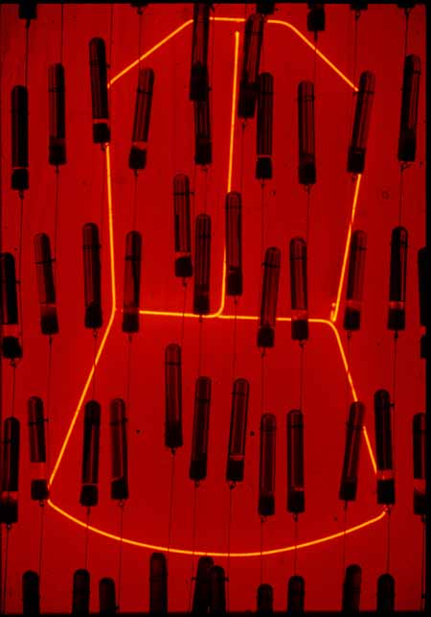
As we are celebrate the rebuff to drilling in the Alaska Wildlife Refuge, native tribes in Alaska are still dealing with the legacies of the first Alaska Native Claims Settlement Act of 1971, the product of the first invasion of oil companies into Alaska. That legacy is the powerful subject of the exhibition “Resisting Acts of Distillation” by Tanis Maria S’eiltin currently on view at the Sacred Circle Gallery of American Indian Art in Discovery Park. Do not miss this show! It is a dramatic aesthetic and technical treat and an informed commentary on an important subject.

In the two rooms of the Sacred Circle space the artist presents traditional Tlingit culture by means of a dramatic print based on a tribal war helmet/mask that was taken from Alaska by an anthropologist in the late nineteenth century. The mask is currently in the Museum of Natural History in New York. Tanis Maria S’eiltin has printed an expressionist interpretation of the mask on deer hide with the original edges of the skins still echoing the shape of the untrimmed skin. (The artist made traditional deer hide art as a child). Hanging from the ceiling, the repeated larger than life-size mask images fill the first gallery, creating a powerful presence.

In the second gallery dozens of vials containing red fluid hang from the ceiling and across one wall, as well as below one more mask image hanging on one wall. The vials refer to the United States government demand that to be considered legally entitled to rights; Native Americans must prove 25 percent native blood. The artist is defying this “quantum” concept with her installation, declaring that native culture has no need of such a definition, that it survives and resists obliteration in its own terms. It refuses to be distilled.

The third component of the exhibition is possibly the most astonishing, for those of us unfamiliar with the impact of the Alaska Native Claims Settlement Act. As the artist explains it “Under the terms of the agreement, aboriginal land claims were dissolved and title to 1/9th of the state’s land was granted to 13 regional and 200 village corporations.”
In other words the United States imposed the model of corporate competition as a means to wealth on the native’s tribes. Anyone born after 1971 cannot become part of a corporation. They are disenfranchised unless someone donates shares of a corporation to them. The Alaskan tribes agreed to sign, thinking it would better their economic situation, but only a few of these corporations have done well, most are struggling to survive. If they fail economically, they lose all rights to their land. On the last wall of the exhibition is a series of prints that refer to these small corporations by name.

Last there is a brilliant red neon shape that hangs behind the blood vials. It outlines a flat copper form that was given as a gift in the Native community and it is a counter to the concept of wealth as accumulated money that is acquired by economic competition. The red shape glows brightly behind the strings of suspended blood vials. Its neon glow beams out the importance of the transformation and respect for traditional values as a means of healing the disrupted society.
Tanis Maria S’eiltin’s act of resistance is both aesthetic and intellectual. She adopts a personal combination of traditional references and avant-garde media and she presents information about historical acts of which most of us are completely ignorant. In doing so she makes an important contribution to the future of Alaskan Tlingit culture.

Tanis Maria S’eiltin “Resisting Act of Distillation”
A multimedia installation April 12 – June 5, 2002
Sacred Circle Gallery of American Indian Art
Daybreak Star Arts Center, Discovery Park

