CATALOG ESSAY
“As you see me, but I am not,” Contemporary Turkish Women Artists, Frauen Museum, Bonn, November 3, 2000 - January 5, 2001, Ministry of Culture of the Turkish Republic, Ankara, 2001
©Susan Platt
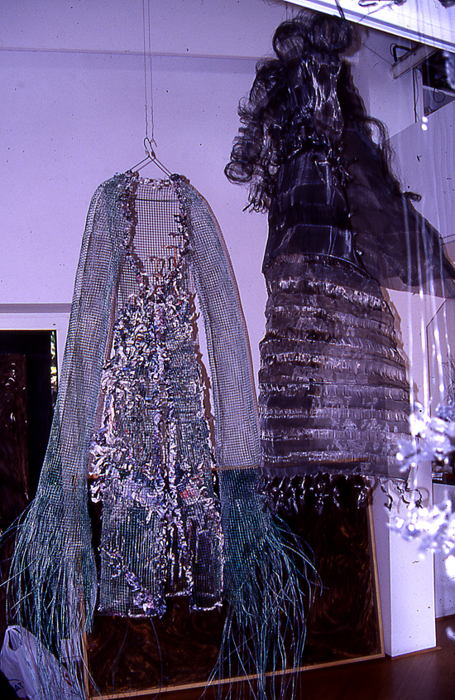©Suzy Hug-Levy
The six artists in this exhibition all address the body, but in very different ways. All of them defy characterization in terms of traditional Euro-American types of analysis of women's art, Turkish art, Orientalism, or any other criteria. Some are trained in Turkey, some abroad, some are politically radical, and others are radical in the media that they choose to use. Some of these artists read postmodern theory, or identify themselves as feminist; others are mainly concerned with the physical act of making art. Above all though, the concept of a marketable "Turkish" identity is not of paramount concern to these artists. To analyze them in that way would be the projection of a Western eye: "as you see me, but I am not." The title is intentionally ungrammatical in English (while it flows perfectly in Turkish), in order to rupture the expected communication, to disrupt preconceived structures.
The main characteristic of the exhibition is that these art works form a testimony to the important contemporary art currently being produced in Turkey. Each artist has made art according to her own perspectives and life experiences, but rather than forming a philosophical or a stylistic group, together they embody an act of defiance.
In the works show here, Tomur Atagök presents the Anatolian mother goddess, Artemis, and other powerful females painted expressionistically on large steel plates. These goddesses are contemporary in their scale and presence, they dominate any setting. They have migrated from the hidden recesses of old cults and graves to preside over our current world. In reference to that world of guns and wars, Atagok has substituted tanks for animals in the center of the Artemis goddess. These goddesses are also seen with their inside organs and their psychological states of mind, they do not simply exist as an icon, but as a multilayered human beings.
Gülsün Karamustafa aggressively and physically deconstructs the Orientalist fantasies of Western European nineteenth century painters. She has enlarged details from these paintings that reveal the artists' racism and ignorance about female anatomy, underscoring the fact that these nude women are simply reduced to desired body parts. In one grouping called Double Action Series for Oriental Fantasies, nearly life size cut outs stand up on their own in the gallery. A man is sticking his fingers into the mouth of an odalisque; a shamed woman hides her face. In another series Gulsun has selected details of breasts, and other sensual areas. The details emphasize the tactile sensuality of the male gaze, removing all references to the woman as person. Gulsun has also combined Orientalist images with texts from the memoirs of Leyla Saz Hanimefendi about the emotional tensions of actual life in the imperial harem. Finally, for Gulsun, the re-contextualizing of these Orientalist fantasies is necessary in order to expose the extent to which their prejudices still govern attitudes towards women from the Middle East.
Nur Kocak paints super realist images of embroidered silk and nylon women'sunderwear. Her paintings are based on the manipulation of her own photographs of shop windows in Istanbul. Always interested in the commodities of women's beauty (another series focused on perfume bottles), the artist here is underscoring the contradictions and ironies between the public presentation of Islamic women as modest and covered, the secular invasions of the commercial sector, and the private life of Muslim women who buy lavish clothes (and particularly underwear) only to please their husbands. At the same time, the paintings are also an exuberant celebration of the colors and textures of these normally secret garments.
Suzy Hug-Levy also concerns herself with dress, but in her case they are shroud like coverings made of wire, gauze, paper, and glue that hang in air, casting shadows. Sometimes she uses nails to contradict the "soft" effect of the mesh, or knotted rags in a reference to a marriage ritual in which a woman binds herself with forty knots which the man has to then undo. Hug-Levy is directly reacting to the rise of Islamist fundamentalism in her work; she addresses the ambiguity of women's position through both the materials she uses and the importance of shadows. In Islamic thought the visible "face" of reality is a shadow of a larger reality that only Allah can perceive. These garments signify that, from Hug-Levy's perspective, women become shadows of shadows as they are absorbed into the Muslim faith.
Inci Eviner went to the margins of modern society to photograph children in the "garbage hills" of Istanbul, the outer perimeter of the city where immigrants build communities overnight (gecekondu), only to have them bulldozed the next morning. Within a vast almost empty landscape, children drag each other around, cling to one another, stand immobilized, or cover their faces with their shirts, exposing their chests. Three of the children are albinos; they dazzle us with their whiteness, even as we are acutely aware of their persecuted position. One of the children holds a stuffed goat, another wears an animal skin. In the foreground of this desolate landscape are strewn a pair of high heeled shoes, a doll, a globe, a dead fish, a shell, a telephone receiver, a book, a meter stick. Although these symbols can be attached to various historical and contemporary traditions, in these photographs they are meaningless except as a signifier of the reinvention of life that is required of the people who immigrate from villages to cities. Eviner's work often focuses on the tensions between traditional society and contemporary social pressures. In these photographs she has presented the place of transition between those two worlds.
Canan Beykal's piece in this exhibition focuses on the body in an entirely different way, she has set up a dialog with "the other" the outsider, in a way that constructs an identity across cultures. In "Tell me where you come from (bana geldigin yeri anlat)" she interrogated foreigners who came to Turkey ( the "other"). She asked them to write a story in their own language or to write a paragraph in response to a question. She paired the writing with a passport photograph, or a photograph that she took herself as well as a drawing that they did on the spot. She thus constructs works that "embody" individuals from many different backgrounds in a multi-dimensional expression that moves beyond the prejudice that comes from a single perspective or a single moment.
All of these artists are not just embodying the "other" in their work, they are also, in the act of making contemporary art, defiantly presenting their own positions, both inside and outside of Turkey. Within Turkey they are secularized, multilingual, internationally sophisticated women who belong to the social and intellectual elite. They are an "other" to the Islamic women in Turkey who have voluntarily chosen to embrace traditional religion for various reasons. These artists are equally "other" to the traditional village women of Turkey and to those who have recently immigrated to Istanbul. Outside of Turkey though, artists from Turkey are perceived simply as the traditional "other" to Europe. That is the reason for the title. As you see them with the eyes of a Westerner who has preconceived ideas about Turkey is not who they are. Who they are is presented in the complex, layered works of this exhibition.

