REVIEW
Staged Sanctity
INCI EVINER: HIÇBIRYER-GÖVDE-BURASI
NOWHERE-BODY-HERE
Kazim Taşhkent Art Gallery Istanbul
March 1-25, 2000
©Susan Platt first published in After Image, July-August 2000
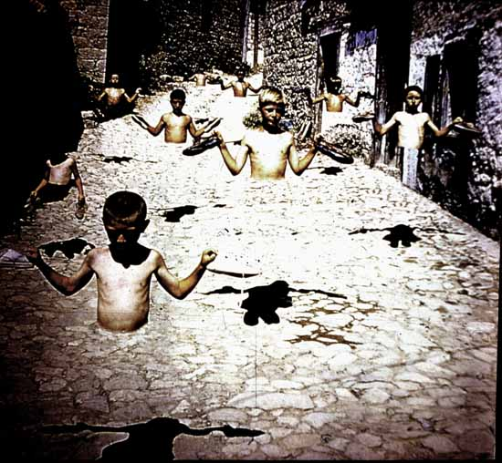
©Inci Eviner

Inci Eviner’s provocative conceptions stimulate anxiety and discomfort. Within a vast dirt landscape, children float (their lower bodies have vanished below the pelvis), drag each other around, cling to one another, stand immobilized, or cover their faces with their shirts, exposing their chests. What is this place, who are these children, why are they there? On the distant horizon are the buildings of an outer suburb of Istanbul called Esentepe, but no story can be constructed, there is no narrative, no past and future, only a present. Within that present these children exist at the border, both physically, and psychologically. Three of the children are albinos; they dazzle us with their whiteness. Even the late afternoon sun, the most intense light that they can tolerate, makes them glow. The other children are dark, their faces are hidden with their long black hair, or their shirts. The Albino children seem to be special, to be almost spiritual, like the anomalous other of a Thousand Plateaus. They seem to bear a special magic, and yet they do not. They are just children, afflicted with a terrible disability that makes them social outcasts.

One of the children holds an animal, a stuffed goat, another wears an animal skin.
In the foreground of this desolate landscape is a pair of silver, high heeled shoes, a doll, a globe, a dead fish, a shell, a telephone receiver, a book, a meter stick. The artist has constructed a world of signs that have many meanings and no meanings, of people that have many meanings, and yet seem without meaning. That is the anxiety. The signs have been assigned meanings like the ‘inevitability of death’, “temptation and libido “melancholy”, ‘culture’, ‘topography’ But the meaning is not there, it is not within the experience of the photograph. In “assigning” meaning, the artist has removed the meaning in some strange reversal. That is the anxiety. Here is a world , a nonworld, without any meaning, without any place, without any history or hope. We are in this border ourselves. The nine mural scaled photographs surround us and we are also immobilized and without any history.
We are part of the absence of body, of place, of meaning.
In two of the photographs, the children sit on an unidentified structure, a stepped building of concrete that may have served an industrial purpose once. In another, the children are in front of a gleaming steel factory that appears on the horizon. The space also includes an unfinished mosque . But these structures also do not have a clear significance. This world is not old, it is not formed, it is not new. It is a non-world.

This space that is constructed in the gallery between the photographs, the non-space, the abstract space, may relate to the space of a mosque, which also embraces us as a nonspace, as a non material reality. It is not a view of heaven, but a view of a non physical reality, a space that can also be experienced from within, not with our eyes.
Yet there is a major difference, for this non space is not occupied by any spirit. It is empty of spirit. It is a void.

On the second floor of the exhibition, which is visible from the immobilized center of the landscapes, is a small house where the stuffed lamb, the fur cape, the book, the doll, the shoes are in compartments. In addition there are jars with sharks and stacks of children’s books with pearls inserted into them. (The artist’s name means pearl in Turkish). At its center the house is blue and empty, but around that center these objects claim the house at the same time that they remove life from the house. In addition to the house, there is a series of watercolors, the images are also becoming body, or not becoming bodies, with photographs of organs joining with the quick strokes of watercolor to construct non forms.

Eviner has been working in manipulated photographic imagery for about three years, first creating collaged images of fish headed people based on old photographs conceptually and technically connect to the works of the early twentieth century like the photomontages of Max Ernst. Yet there is in Eviner’s use of fish imagery, a not symbolic, a removal of meaning, rather than an adding of cosmological layers. For her digital photography, Eviner constructs a scene with street children, whom she pays as you would actors for a play, then has the photograph executed . Another recent series, executed in a village in central Anatolia, has children who seem to be embedded in a street, about to fly away, but unable to because they are immobilized. There lower bodies, their legs are missing.
Eviner is removing meaning, rather than adding it, as she works. She sets up what appears to be symbolic scenes laden with references, but they do not speak. They are constructed in a way that removes meaning. They suggest a profound disjunction between the artist and the society in which she is working, a sense that she herself is frozen. That she like the children she photographs is immobilized at a border of society, an anomalous other, who cannot move, who cannot connect, who cannot live. The Deleuzian model of the body without organs comes to mind, for these children, and the other objects in the photographs. They are not alive, are not living in this world. They are the other.
Eviner, as a middle class woman in modern Turkey, lives in a privileged space, but as the single mother of a teenage son, she is in a socially unacceptable position. As the educated daughter of a family from central Anatolia, she is liberated, but socially she is imprisoned in traditional expectations. As a postmodern artist, she has access to the world, as an artist from Turkey, she is an “Other” who is marginal, on a border, unable to fly away, or to construct a world with meaning within the society where she lives, just like the children that she photographs.
After Image, July-August 2000

