REVIEW

“Dangerous Things” Karşı Gallery, Istanbul, October 1-31, 2002
©Susan Platt first published in Art Papers March April 2003

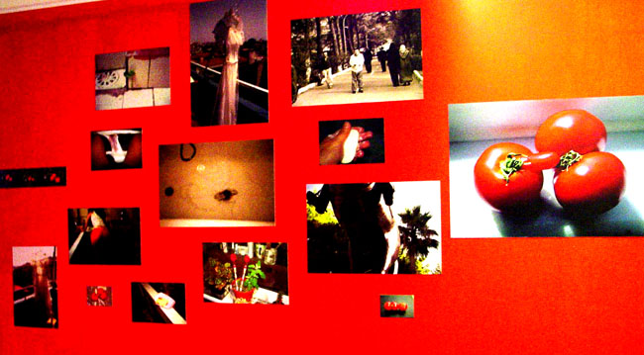
Neriman Polat Installation “Spoilt”
New trends, new artists, new historical exhibitions emerged this fall in Istanbul. Dangerous Things curated by Levent Çalıkoğlu spoke to the artificial, institutional and real dangers of contemporary life, definitely a current international preoccupation. The fifteen artists each took a different aspect of danger - falling off a train platform (Gül Ilgaz), circumcision - a big issue in Islamic societies since boys are not circumcised until they are about seven- (Juan Botella Lucas), gun violence (Burak Özdelice), fire (Merih Akoğul), international traffic in kidnapped children and drugs (Denizhan Özer), medical crises (Nalan Yırtmaç) drowning (Mukadder Şimşek) and domestic pressures on women (Neriman Polat), to name only the works which I found the most compelling. With the exception of circumcision, these are subjects artists anywhere might address in the context of the theme of this exhibition. Likewise, the media is that of all international artists, video, film, sound, photography and digitally manipulated images as well as some painting and drawing. I asked Taner Ceylan why exquisite drawings of his own head were dangerous, and he responded that his tension-filled images of homoerotic lovers had been attacked, so his self-portrait suggests the personal threats he has experienced. These young Turkish artists, as well as the curator, are participating in international anxieties. No wonder. The biggest “dangerous thing” the war in Iraq, is right in their backyard and will devastate their economy and possibly even their country.

In partnership with this small focused exhibition, the survey “60 Years 60 Artists” (Eczacıbaşı Sanal Müzesi, Tüyüp Book and Art Fair October 25 – November 3, 2002, Istanbul) marked the first time that the virtual art museum www.sanalmuze.org has created an exhibition on the ground so to speak. I found the choices of both artists and media compelling, with their combination of well-known modernist painters and sculptors and young postmodernists. One of the more provocative works was Denizhan Özer’s In the Same Plane as a Pentagon, (2000) which had photo booth strips of Islamic-looking men (including the artist) who look like our mug shots of terrorists, arranged on a five sided brazier. In the center were scattered plastic alphabet letters that can refer to our cultural miscommunications, coded messages, government confusion or whatever we wish. The photographs were all on skewers, being roasted over the (pseudo)coals. The partner to this work was Erdağ Aksel’s Pandoraprism (1988). Aksel’s dark work refers to militarism but with humor. A metal helmet on a spring pops up through the top of a shortened obelisk like a sardonic jack-in-the-box. ( see chapter one) Yusuf Taktak also works with obelisks. Explanations about my Obelisk (2001) refers to his long series on obelisks (a famous example from Egypt sits at the center of the oldest area of Istanbul, near Hagia Sophia), but here his lively painting and (illegible) guide suggest a humorous new direction. One of my favorite younger artists is Elif Çelebi, whose theme is often the tempo of the natural world in relationship to people and urban settings. In this case, she filmed a mouse as it moved around a small grocery store. Çelebi also works with snails and grasshoppers, among other creatures.

