CATALOG ESSAY

Goddess Series, Tomur Atagök
© Susan Platt 2000
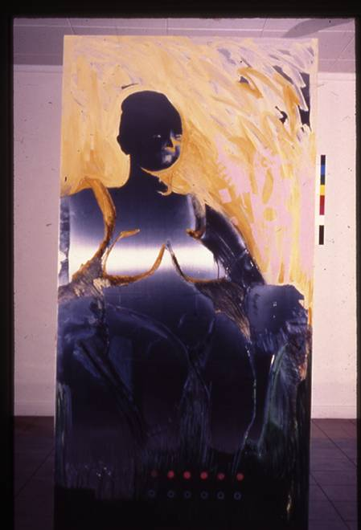

Tomur Atagök's "Goddess Series" is part of a long series of works that extends back to the early 1980s that look at many aspects of women in contemporary society as well as the ancient Goddesses. From Medusa to Madonna, Atagok has painted women. She includes contemporary ordinary women as well as famous icons, but these unknown women are all energetic: they exercise, they dance and they flamboyantly participate in contemporary life.
The large reflective metal surfaces assertively painted in primarily pinks and reds reflect, both literally and figuratively, the historical power of women in Neolithic times. Dominating this series is the great Anatolian Mother Goddess from Çatalhöyük. That twenty centimeter statuette, excavated from the oldest city in the world, dates from around 5700 BC. The small figure has enormous power: she is seated comfortably between subdued leopards as she gives birth. Her breasts, hips and buttocks swell to enormous proportions, further increasing her power. Far removed from the slender, even emaciated, ideal for a female body that is now common for some contemporary societies (notably the United States), this goddess proclaims her physical presence and her authority at the same time.
In the paintings by Tomur Atagök, the Goddess assumes much larger dimensions as she joins our world as a life size figure who stands as a guardian. Rather than a fertility symbol, she is now a symbol simply of the power of women. She is an affirmation of women's energy and authority. On her head she wears a type of mechanical diadem/crown in one painting, and sits in front of a golden shower of sun in another. These two large goddesses frame a third panel that makes reference to the interior of woman, specifically here, the vertebrae and ovaries. The woman's interior, so often altered today by contemporary medical science, is here protected by powerful traditional forces.
Another of these grand paintings is based on Artemis of Ephesus. Artemis, later changed to a slender virgin hunter by the Romans, is here seen in her guise as Cybele, the Anatolian mother goddess. Her many breasts carry the power of nurturing and life. In place of the animals under her protection on the traditional statues, this painting has guns, tanks and other references to military warfare. Artemis also has black gloves and a contemporary face with bold red lipstick and blond hair. It was done in response the violation of sacred lands by military weapons, particularly during the Gulf War. This powerful statement could be about any war and its destructive effect on life as a whole
The collective presence of these goddesses is a powerful commentary on contemporary women and their connection to historical traditions. Painted in a technique that has its roots in abstract expressionism, they are major examples of contemporary art in Turkey.

